PUBLIC SECTOR EQUALITY DUTIES

BSMHFT ANNUAL EQUALITY MONITORING REPORT
For the period of January 2018 – December 2018

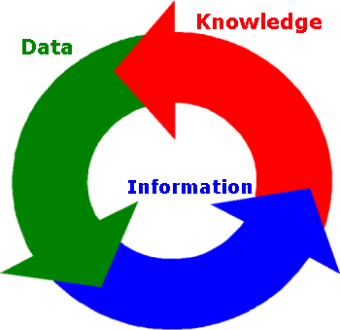

Author: Bina Saini, Senior Equality Diversity and Inclusion Lead

Recipient: Workforce Sub-committee
Clinical Commissioning Group

Date: April 2019

BIRMINGHAM AND SOLIHULL MENTAL HEALTH NHS FOUNDATION TRUST

April 2019

ANNUAL EQUALITY MONITORING REPORT for the period of January 2018 –December 2018
Executive Summary
Birmingham and Solihull Mental Health NHS Foundation Trust provides mental health care, serving a culturally and socially diverse population of 1.3 million people spread over 172 square miles. We are one of the largest Mental Health Foundation Trusts. We provide specialised services for the people of Birmingham and Solihull. Our catchment population is ethnically diverse and characterised in places by high levels of deprivation, low earnings and unemployment.

We are passionate about improving mental health wellbeing by making a positive difference to people’s lives and believe that equality, diversity and inclusion is at the heart of achieving our vision

Purpose of Report
As a requirement of the Equality Act 2010 – Public Sector Equalities Duty, all public bodies are obliged to publish their equality objectives and data on how they will work towards the implementation of equality, diversity and human rights to:

- Eliminating discrimination
- Promote Equality of Opportunity
- Advance equality
- Fostering good relations between personal protected characteristics

This report is to publish our Equality Data from January 2018 to December 2018 as required by the Public Sector Equality Duty. Analysis of the data will assist the Trust in embedding initiatives into its Equality, Diversity and Inclusion (EDI) Framework for 2017-2020.

Our strategic ambitions are the six key areas that describe how we will achieve our vision:

- Put service users first and provide the right care, closer to home, whenever it’s needed

- Listen to and work alongside service users, carers, staff and stakeholders

- Champion mental health wellbeing and support people in their recovery

- Attract, develop and support an exceptional and valued workforce

- Drive research, innovation and technology to enhance care

- Work in partnership with others to achieve the best outcomes for local people to enhance care.

Equality, Diversity and Inclusion (EDI) Framework

This Framework should be read in conjunction with other relevant policies, procedures and strategies including the Trust Strategy, People Plan, the Health and Wellbeing Plan and the Behavioural Competency Framework.

BSMHFT takes its obligations under Equality Legislation seriously and aims to provide fair and equitable treatment to, and value diversity in, its staff, service users and communities. In doing so we aim to ensure that our actions and working practices comply with both the spirit and intention of the Human Rights Act (1998) and the Equality Act (2010)

The promotion of equality and achieving the elimination of unlawful discrimination within the organisation is a key priority. This will be achieved by ensuring the philosophy of equality, diversity and inclusion runs through all aspects of policymaking, service redesign, service provision and employment and forms part of the core of the organisation.

We are committed to building on the work we have already been doing and focus on inclusion every day; this means that we wish to make it real to everyone by embedding inclusion in everything we do. We are striving to be the very best we can be. We are taking the opportunity to be a pioneer in this field and enhance the daily experience of our staff, members, patients and communities.

This framework will address health inequalities including complying with relevant legal duties (e.g. the Equality Act 2010) and national standards (e.g. Equality Delivery System (EDS2), the Workforce Race Equality Standard (WRES) the Workforce Disability Equality Standard (WDES) and the Accessible Information Standard (AIS). It is underpinned by two core principles;

- Embed equality of opportunity, and create services and care pathways that reduce wide variations in health outcomes for protected and vulnerable groups

- Ensure fairness and equity in relation to employment, based upon the values of the NHS Constitution.

It will be underpinned by an action plan, outlining the steps we will take to ensuring that equality, inclusion and human rights are imbedded in everything we do. This includes providing services, employing people, developing policies, and consulting with and involving people in our work, and will enable us to communicate and manage equality commitments to create a culture of inclusion.

The EDI Framework demonstrates how we will:
- Maximise our contribution to reducing inequalities and promoting equality of access, experience and outcomes.
- Become a model employer in respect of equality, diversity and inclusion in employment
- Comply fully with current and future equality and human rights legislation
- Ensure our services are accessible to all and support a diverse workforce that is capable of understanding the needs and culture of its service users and staff.

To improve the equality outcomes for patients, and carers we are committed to:

- Improve access, experience and outcomes for people identified by the protected characteristics when using or providing our services

- Make information more accessible and specific to patients who have a clinical need.

To improve the equality outcomes for our workforce we are committed to:

- Ensuring fair and transparent recruitment practices are in place using a wide variety of advertising mediums and taking positive action to reach out to diverse communities.

- Increase the diversity of people in leadership and management roles through ensuring we have fair and transparent promotion processes

- Continue to build a strong and positive culture of inclusion

- Improve our collection and use of equality data.

To share our leadership of inclusion across our community we are committed to:

- Broaden our reach to voluntary partners and communities in order to gain different perspectives.

- Involve communities in equality impact assessments and identifying remedial action to be taken where adverse impact is identified

- Engaging and working jointly with seldom heard and socially excluded groups (e.g. disabled, LGBT and BAME groups) to develop sustainable initiatives in response to identified inequalities

Enablers
The delivery of the EDI Plan is dependent on a number of key enablers:

- Supportive strategic leadership and strong governance

- Effective communications with service users, staff and external stakeholders

- Training for staff at all levels

- Partnership working with local stakeholders and interests

- Engaging corporate and operational teams

Our Approach

We know that engaging with staff, service users and communities in a meaningful and sustained way is important in helping to make continuous improvements on the inclusion agenda.

We will seek to better understand why some staff often receive much poorer treatment than other staff in the workplace and why service users from some communities experience more coercive treatment and are less satisfied with services. We are committed to opening opportunities for open dialogue and be fully engaged in dynamic conversations. By clearing our preconceptions and actively listening we want to understand why the gaps exist. We want to be curious, be open, challenge existing thinking and strive to do things differently.
Workforce Equality Data – Appendix 1
The Public Sector Equality Duty requires that we gather, analyse and publish equality data on all of the Personal Protected Characteristics on our workforce.
Analysis of the workforce data 2018 highlights
- A general improvement in the quality and completeness of the information held in ESR
- Continuance to improve data collection is needed to carry out effective analysis of our workforce data in order to meet the Public Sector Equality Duty, NHS Race Equality Standard and NHS Disability Equality Standard.
- The Trust has an ageing workforce therefore the Trust needs to establish skill sets are being maintained and policies and procedures are updated to offer flexibility.
- The widening participation programme aims to review its processes during 2019-2020
- Improvement in the appointment of BAME staff in some categories across the workforce However, there remains a number of key challenges for the trust such as:
- The retention of BME staff after they have been appointed
- The progression and development of BAME staff at certain management bands
- Continue to address the high proportions of “Not Stated” or “Unknowns” across all of the protected characteristics
Service User Data – Appendix 2
The Equality Act 2010 and the Public Sector Equality Duty places a mandatory requirement on the Trust to gather, analyse and publish Service User equality data on an annual basis against the 9 Personal Protected Characteristics identified by the Equality Act 2010.
The analysis of this information assists the Trust to identify areas of health inequality and take appropriate actions and set objectives to improve the quality of service that is provided.
The data provides details of the information that has been collected for the term running from January to December 2018. The analysis of the information will be used to influence the decision making process for the Trust in both service provision and workforce planning.
Analysis of the 2018 service user data shows that:
- The highest age group remains as 30 to 44 at 27.32%, followed by 45 to 59% at 22.64%
- In relation to Gender 56.16% of service users are female and 43.80% are male.
- 30.47% of service users are from BAME background, with British Pakistani continuing to being the highest BAME service user at 7.72% followed by Black African Caribbean at 4.73% and Asian British Indian at 3.34%.
- The most challenging areas however are as follows:
- There is limited information collected on Transgender. The Trust hope to see an improvement on this with the Sexual Orientation Monitoring (SOM) standard coming into force and internal systems being improved to capture this date.
- There are still high areas on “not known” Our ability to collect equality data must remain a priority and focus will be placed on operational areas in order to address this issue.
The Trust is fully committed to the equality, diversity and inclusion agenda and we have a clear understanding of our responsibilities from the Public Sector Equality Duty. We strive to deliver a service that is fair and equitable to the varied and diverse population we serve and to create a safe and inclusive working environment where people from all sectors of the community can come to work and feel valued, provided with the support and development required so that they can reach their full potential.

APPENDIX 1 - Workforce Equality Data
APPENDIX 2 - Service User Data

APPENDIX 1
Birmingham and Solihull Mental Health NHS Foundation Trust
Equality and Diversity Workforce Data Report
January 2018 – Dec 2018
If you require this in a different format e.g. larger print, Braille, different languages or audio tape, please contact the HR Department on 0121 301 1257 or email HR.support@bsmhft.nhs.uk
TABLE 1: Workforce Age Profile
 | 2018
Age Range | Headcount | 2018 | 2017 | 2016 | 2015 | 2014 | 2013 | 2012
<20 | 9.00 | 0.2% | 0.4% | 0.6% | 0.5% | 0.5% | 0.1% | 0.1%
20-29 | 582 | 14.7% | 14.2% | 14.3% | 14.7% | 14.7% | 14.3% | 13.1%
30-39 | 922 | 23.3% | 23.1% | 23.1% | 24.5% | 24.5% | 25.7% | 25.0%
40-49 | 1055 | 26.7% | 28.2% | 28.6% | 29.0% | 29.0% | 30.8% | 32.7%
50-59 | 1114 | 28.2% | 27.5% | 26.9% | 25.7% | 25.7% | 23.8% | 23.6%
60-64 | 209 | 5.3% | 5.1% | 4.8% | 4.4% | 4.4% | 4.2% | 4.5%
>65 | 63 | 1.6% | 1.6% | 1.6% | 1.2% | 1.2% | 1.2% | 1.0%
Grand Total | 3954 | 100.00% | 100.00% | 100.00% | 100.00% | 100.00% | 100.00% | 100.00%
The analysis above continues to indicates the Trust has an aging workforce with an increase of headcount from age 50 plus compared to 2017 and earlier years.
TABLE 2: Workforce Disability Profile
 | 2018
Headcount | Headcount | 2018 | 2017 | 2016 | 2015 | 2014 | 2013 | 2012
No | 3384 | 86% | 88% | 91% | 93% | 93% | 61% | 57%
Not Declared/Undefined | 406 | 10% | 8% | 5% | 3% | 3% | 36% | 41%
Yes | 164 | 4% | 4% | 4% | 4% | 4% | 3% | 3%
Grand Total | 3954 | 100% | 100% | 100% | 100% | 100% | 100% | 100%
In table 2 there has been an increase once again in the category of staff not declaring or undefined their disability compared to previous years. The Trust understands the importance of data collection and is working with the Disability and Neurodiversity Staff Network, long with its other staff networks to encourage staff to be open and honest without feeling categorized.

TABLE 3: Religion and Belief Profile
 | 2018
Religion | Headcount | 2018 | 2017 | 2016 | 2015 | 2014 | 2013 | 2012
Atheism | 353 | 9% | 9% | 9% | 8% | 8% | 6% | 5%
Buddhism | 12 | 0% | 0% | 0% | 0% | 0% | 0% | 0%
Christianity | 1583 | 40% | 41% | 41% | 40% | 39% | 36% | 34%
Hinduism | 78 | 2% | 2% | 2% | 2% | 2% | 1% | 1%
Islam | 223 | 6% | 6% | 5% | 5% | 4% | 4% | 3%
Jainism | 0 | 0% | 0% | 0% | 0% | 0% | 0% | 0%
Judaism | 6 | 0% | 0% | 0% | 0% | 0% | 0% | 0%
Other | 270 | 7% | 6% | 7% | 6% | 6% | 5% | 5%
Sikhism | 97 | 2% | 2% | 2% | 2% | 2% | 2% | 2%
I do not wish to disclose my religion/ belief | 257 | 6% | 31% | 34% | 36% | 15% | 7% | 7%
Not Declared/ Undefined | 1075 | 27% | 9% | 0% | 1% | 24% | 38% | 44%
Grand Total | 3954 | 100% | 100% | 100% | 100% | 100% | 100% | 100%
In Table 3 above there has been a substantial improvement in the I do not wish to disclose my religion/belief compared to 2017, however more work still needs to take place to improve the Not Declared/Undefined category which has increased significantly since last year.
TABLE 4: Gender (SEX) Profile
 | 2018
Gender | Headcount | 2018 | 2017 | 2016 | 2015 | 2014 | 2013 | 2012
Female | 2808 | 71% | 71% | 71% | 71% | 72% | 70% | 70%
Male | 1146 | 29% | 29% | 29% | 29% | 30% | 30% | 30%
Grand Total | 3954 | 100% | 100% | 100% | 100% | 100% | 100% | 100%
Very little has changed in the table above. However more work needs to be done to include other categories into this section such as gender identity and gender expression.

TABLE 5: Sexual Orientation Profile
 | 2018
Sexual Orientation | Headcount | 2018 | 2017 | 2016 | 2015 | 2014 | 2013 | 2012
Bisexual | 31 | 1% | 1% | 1% | 1% | 0% | 0% | 0%
Gay | 69 | 2% | 1% | 1% | 1% | 1% | 1% | 1%
Heterosexual | 2593 | 66% | 65% | 64% | 62% | 59% | 51% | 45%
Lesbian | 1004 | 25% | 1% | 1% | 1% | 1% | 0% | 0%
I do not wish to disclose my sexual orientation | 1 | 0% | 30% | 34% | 35% | 13% | 6% | 6%
Not Declared/Undefined | 256 | 6% | 3% | 0% | 1% | 27% | 41% | 47%
Grand Total | 3954 | 100% | 100% | 100% | 100% | 100% | 100% | 100%
Table 5 highlights a slight improvement in the number of a staff who have disclosed their sexual orientation. However the number of Not Declared/Undefined has seen an increase once again.

TABLE 6: Ethnicity Profile. Table 6 below highlights White British remain the highest representative group in the Trust and for the population of Birmingham. All the Asian or British Asian groups have seen an increase compared to 2017. Most of Black or Black British groups have fluctuated slightly similarly like other groups compared to last year.
Ethnicity | 2009 | 2010 | 2011 | 2012 | 2013 | 2014 | 2015 | 2016 | Trust Profile 2017 | Trust Profile 2018 | Birmingham Population | Solihull Population | Birmingham & Solihull Population
Asian or British Asian | Bangladeshi | 0.50% | 0.005 | 0.006 | 0.005 | 0.005 | 0.006 | 0.006 | 0.0058 | 0.59% | 0.71% | 3.00% | 0.30%
 | Indian | 6.00% | 5.90% | 6.30% | 6.70% | 6.20% | 6.40% | 6.30% | 6.21% | 6.37% | 6.3% | 6.00% | 3.40%
 | Other Asian | 1.40% | 1.30% | 1.30% | 1.20% | 1.30% | 1.30% | 1.60% | 1.31% | 1.16% | 1.0% | 2.90% | 0.007
 | Pakistani | 2.50% | 2.50% | 2.70% | 2.50% | 2.90% | 3.10% | 3.70% | 3.46% | 3.82% | 3.7% | 13.50% | 1.70%
Black or Black African | Black African | 6.60% | 6.30% | 6.70% | 6.80% | 7.00% | 7.20% | 7.40% | 7.52% | 7.77% | 7.8% | 2.80% | 0.40%
 | Black Caribbean | 9.10% | 9.20% | 8.90% | 8.70% | 8.90% | 9.00% | 8.80% | 8.51% | 8.21% | 8.4% | 4.40% | 0.90%
 | Other Black | 0.90% | 1.00% | 1.00% | 1.00% | 1.00% | 1.10% | 1.00% | 1.00% | 1.01% | 1.04% | 1.70% | 0.20%
Chinese | Chinese | 0.20% | 0.30% | 0.30% | 0.30% | 0.30% | 0.40% | 0.40% | 0.40% | 0.36% | 0.3% | 1.20% | 0.40%
Mixed | Other Mixed | 0.30% | 0.40% | 0.40% | 0.40% | 0.50% | 0.60% | 0.60% | 0.77% | 0.62% | 0.71% | 0.80% | 0.30%
 | White & Asian | 0.40% | 0.40% | 0.50% | 0.50% | 0.50% | 0.50% | 0.50% | 0.40% | 0.44% | 0.6% | 1.00% | 0.60%
 | White & Black African | 0.40% | 0.50% | 0.50% | 0.50% | 0.40% | 0.40% | 0.50% | 0.35% | 0.34% | 0.28% | 0.30% | 0.10%
 | White & Black Caribbean | 1.20% | 1.20% | 1.30% | 1.40% | 1.60% | 1.90% | 2.10% | 1.87% | 1.78% | 1.87% | 2.30% | 1.20%
Other Ethnic Group | Other Ethnic Group | 1.20% | 1.10% | 1.00% | 1.00% | 0.90% | 1.00% | 0.90% | 0.91% | 1.08% | 1.11% | 2.00% | 1.00%
Undefined | Not Stated | 8.60% | 8.10% | 7.30% | 7.20% | 6.80% | 5.20% | 6.60% | 8.00% | 9.94% | 12.24% | 0.00% | 0.00%
White | British | 54.50% | 55.30% | 55.20% | 55.30% | 55.30% | 55.20% | 53.70% | 53.10% | 51.28% | 48.84% | 53.10% | 85.80%
 | Gypsy or Irish Traveller | 0.00% | 0.00% | 0.00% | 0.00% | 0.00% | 0.00% | 0.00% | 0.00% | 0.00% | 0.03% | 0.00% | 0.00%
 | Irish | 3.90% | 3.60% | 3.50% | 3.30% | 2.90% | 2.80% | 2.40% | 2.30% | 2.19% | 2.15% | 2.10% | 1.90%
 | Other White | 2.40% | 2.50% | 2.50% | 2.90% | 2.90% | 3.20% | 3.10% | 3.30% | 3.05% | 2.86% | 2.70% | 1.40%
Grand Total |  | 100.10% | 100.10% | 100.00% | 100.20% | 99.90% | 99.90% | 100.20% | 99.99% | 100.01% | 100.00% | 99.80% | 100.30%

TABLE 7: Recruitment Data by Protected Characteristics
Category | Applications | % Applications | Shortlisted | % Shortlisted | Appointed | % Appointed
Gender
Male | 4232 | 24.9 | 2823 | 25.3 | 196 | 22.4
Female | 12703 | 74.6 | 8304 | 74.3 | 678 | 77.4
I do not wish to disclose | 83 | 0.5 | 48 | 0.4 | 2 | 0.2
Not stated | 0 | 0 | 0 | 0 | 0 | 0
Total | 17018 | 100 | 11175 | 100 | 876 | 100
Age
Under 20 | 422 | 2.5 | 331 | 3 | 15 | 1.7
20 - 24 | 3498 | 20.6 | 2718 | 24.3 | 117 | 13.4
25 - 29 | 3530 | 20.7 | 2459 | 22 | 176 | 20.1
30 - 34 | 2481 | 14.6 | 1622 | 14.5 | 137 | 15.6
35 - 39 | 1864 | 11 | 1119 | 10 | 106 | 12.1
40 - 44 | 1531 | 9 | 880 | 7.9 | 94 | 10.7
45 - 49 | 1514 | 8.9 | 851 | 7.6 | 94 | 10.7
50 - 54 | 1258 | 7.4 | 718 | 6.4 | 75 | 8.6
55 - 59 | 701 | 4.1 | 361 | 3.2 | 49 | 5.6
60 - 64 | 175 | 1 | 92 | 0.8 | 13 | 1.5
65+ | 42 | 0.2 | 23 | 0.2 | 0 | 0
Not stated | 2 | 0 | 1 | 0 | 0 | 0
Total | 17018 | 100 | 11175 | 100 | 876 | 100
Ethnic Origin
WHITE - British | 6963 | 40.9 | 4334 | 38.8 | 457 | 52.2
WHITE - Irish | 183 | 1.1 | 106 | 0.9 | 17 | 1.9
WHITE - Any other white background | 559 | 3.3 | 419 | 3.7 | 15 | 1.7
ASIAN or ASIAN BRITISH - Indian | 1643 | 9.7 | 1168 | 10.5 | 66 | 7.5
ASIAN or ASIAN BRITISH - Pakistani | 2033 | 11.9 | 1589 | 14.2 | 49 | 5.6
ASIAN or ASIAN BRITISH - Bangladeshi | 456 | 2.7 | 353 | 3.2 | 10 | 1.1
ASIAN or ASIAN BRITISH - Any other Asian background | 256 | 1.5 | 172 | 1.5 | 9 | 1
BLACK or BLACK BRITISH - Caribbean | 1322 | 7.8 | 796 | 7.1 | 65 | 7.4
BLACK or BLACK BRITISH - African | 1742 | 10.2 | 1025 | 9.2 | 84 | 9.6
BLACK or BLACK BRITISH - Any other black background | 158 | 0.9 | 106 | 0.9 | 7 | 0.8
MIXED - White & Black Caribbean | 499 | 2.9 | 330 | 3 | 32 | 3.7
MIXED - White & Black African | 71 | 0.4 | 43 | 0.4 | 4 | 0.5
MIXED - White & Asian | 144 | 0.8 | 88 | 0.8 | 14 | 1.6
MIXED - any other mixed background | 168 | 1 | 107 | 1 | 10 | 1.1
OTHER ETHNIC GROUP - Chinese | 49 | 0.3 | 30 | 0.3 | 3 | 0.3
OTHER ETHNIC GROUP - Any other ethnic group | 239 | 1.4 | 158 | 1.4 | 9 | 1
I do not wish to disclose my ethnic origin | 63 | 0.4 | 38 | 0.3 | 6 | 0.7
Not stated | 470 | 2.8 | 313 | 2.8 | 19 | 2.2
Total | 17018 | 100 | 11175 | 100 | 876 | 100
Disability
No | 15712 | 92.3 | 10318 | 92.3 | 805 | 91.9
Yes | 919 | 5.4 | 607 | 5.4 | 45 | 5.1
I do not wish to disclose whether or not I have a disability | 368 | 2.2 | 250 | 2.2 | 12 | 1.4
Not stated | 19 | 0.1 | 0 | 0 | 14 | 1.6
Total | 17018 | 100 | 11175 | 100 | 876 | 100
Guaranteed interview scheme
No | 2600 | 15.3 | 1672 | 15 | 228 | 26
Yes | 647 | 3.8 | 453 | 4.1 | 24 | 2.7
Not stated | 13771 | 80.9 | 9050 | 81 | 624 | 71.2
Total | 17018 | 100 | 11175 | 100 | 876 | 100
Disability Description
Physical impairment | 119 | 0.7 | 93 | 0.8 | 1 | 0.1
Sensory impairment | 83 | 0.5 | 62 | 0.6 | 7 | 0.8
Mental health condition | 158 | 0.9 | 102 | 0.9 | 12 | 1.4
Learning disability/difficulty | 201 | 1.2 | 139 | 1.2 | 11 | 1.3
Long-standing illness | 177 | 1 | 102 | 0.9 | 5 | 0.6
Other | 181 | 1.1 | 109 | 1 | 9 | 1
I do not wish to disclose whether or not I have a disability | 13735 | 80.7 | 9041 | 80.9 | 608 | 69.4
Not stated | 2364 | 13.9 | 1527 | 13.7 | 223 | 25.5
Total | 17018 | 100 | 11175 | 100 | 876 | 100
Sexual Orientation
Bisexual | 265 | 1.6 | 187 | 1.7 | 14 | 1.6
Gay | 95 | 0.6 | 50 | 0.4 | 5 | 0.6
Heterosexual or Straight | 15360 | 90.3 | 10129 | 90.6 | 782 | 89.3
Lesbian | 64 | 0.4 | 40 | 0.4 | 6 | 0.7
I do not wish to disclose my sexual orientation | 992 | 5.8 | 638 | 5.7 | 37 | 4.2
Gay or Lesbian | 176 | 1 | 99 | 0.9 | 16 | 1.8
Other sexual orientation not listed | 14 | 0.1 | 7 | 0.1 | 0 | 0
Undecided | 33 | 0.2 | 25 | 0.2 | 2 | 0.2
Not stated | 19 | 0.1 | 0 | 0 | 14 | 1.6
Total | 17018 | 100 | 11175 | 100 | 876 | 100
Transgender
Not stated | 17018 | 100 | 11175 | 100 | 876 | 100
Total | 17018 | 100 | 11175 | 100 | 876 | 100
Marital Status
Single | 9944 | 58.4 | 6852 | 61.3 | 477 | 54.5
Married | 5261 | 30.9 | 3206 | 28.7 | 289 | 33
Civil partnership | 386 | 2.3 | 277 | 2.5 | 15 | 1.7
Legally separated | 130 | 0.8 | 73 | 0.7 | 7 | 0.8
Divorced | 599 | 3.5 | 350 | 3.1 | 44 | 5
Widowed | 71 | 0.4 | 42 | 0.4 | 5 | 0.6
Other | 93 | 0.5 | 63 | 0.6 | 8 | 0.9
I do not wish to disclose this | 58 | 0.3 | 28 | 0.3 | 5 | 0.6
Not stated | 476 | 2.8 | 284 | 2.5 | 26 | 3
Total | 17018 | 100 | 11175 | 100 | 876 | 100
Religion
Atheism | 1971 | 11.6 | 1258 | 11.3 | 147 | 16.8
Buddhism | 103 | 0.6 | 76 | 0.7 | 4 | 0.5
Christianity | 7309 | 42.9 | 4499 | 40.3 | 397 | 45.3
Hinduism | 481 | 2.8 | 340 | 3 | 24 | 2.7
Islam | 2995 | 17.6 | 2320 | 20.8 | 69 | 7.9
Jainism | 5 | 0 | 4 | 0 | 0 | 0
Judaism | 12 | 0.1 | 4 | 0 | 0 | 0
Sikhism | 725 | 4.3 | 483 | 4.3 | 30 | 3.4
Other | 1628 | 9.6 | 1063 | 9.5 | 89 | 10.2
I do not wish to disclose my religion/belief | 1770 | 10.4 | 1128 | 10.1 | 102 | 11.6
Not stated | 19 | 0.1 | 0 | 0 | 14 | 1.6
Total | 17018 | 100 | 11175 | 100 | 876 | 100
Convictions
Applicant has indicated that they may have convictions which should be taken into account | 298 | 1.8 | 163 | 1.5 | 24 | 2.7
Applicant has indicated that they DO NOT have convictions which should be taken into account | 16701 | 98.1 | 11012 | 98.5 | 838 | 95.7
Not stated | 19 | 0.1 | 0 | 0 | 14 | 1.6
Total | 17018 | 100 | 11175 | 100 | 876 | 100

TABLE 8: % of staff working part time by age group
 | 2018 |  |  |  | 2017 |  |  |  | 2016 |  |  |  | 2015
 | Headcount |  | %Headcount |  | Headcount |  | %Headcount |  | Headcount |  | %Headcount |  | Headcount |  | %Headcount
Age Range | Full Time | Part Time | Full Time | Part Time | Full Time | Part Time | Full Time | Part Time | Full Time | Part Time | Full Time | Part Time | Full Time | Part Time | Full Time | Part Time
<20 | 9 |  | 0.29% | 0.00% | 14 | 3 | 0.46% | 0.36% | 23 | 2 | 0.70% | 0.20% | 17 | 3 | 0.50% | 0.30%
20-29 | 535 | 47 | 17.35% | 5.40% | 490 | 59 | 16.14% | 7.02% | 502 | 64 | 16.40% | 7.20% | 544 | 71 | 16.70% | 7.70%
30-39 | 669 | 253 | 21.69% | 29.08% | 665 | 229 | 21.91% | 27.26% | 679 | 235 | 22.10% | 26.30% | 765 | 258 | 23.50% | 28.00%
40-49 | 792 | 263 | 25.68% | 30.23% | 836 | 256 | 27.55% | 30.48% | 859 | 276 | 28.00% | 30.90% | 926 | 285 | 28.40% | 30.90%
50-59 | 898 | 216 | 29.12% | 24.83% | 861 | 203 | 28.37% | 24.17% | 849 | 218 | 27.70% | 24.40% | 862 | 214 | 26.50% | 23.20%
60-64 | 148 | 61 | 4.80% | 7.01% | 134 | 64 | 4.42% | 7.62% | 128 | 64 | 4.20% | 7.20% | 117 | 69 | 3.60% | 7.50%
>65 | 33 | 30 | 1.07% | 3.45% | 35 | 26 | 1.15% | 3.10% | 28 | 35 | 0.90% | 3.90% | 27 | 22 | 0.80% | 2.40%
Grand | 3084 | 870 | 100.00% | 100.00% | 3035 | 840 | 100.00% | 100.00% | 3068 | 894 | 100.00% | 100.00% | 3258 | 922 | 100.00% | 100%

TABLE 9: % of staff working part time by Gender (sex)
 | 2018 |  |  |  | 2017 |  |  |  | 2016 |  |  |  | 2015
 | Headcount |  | %Headcount |  | Headcount |  | %Headcount |  | Headcount |  | %Headcount |  | Headcount |  | %Headcount
Gender | Full Time | Part Time | Full Time | Part Time | Full Time | Part Time | Full Time | Part Time | Full Time | Part Time | Full Time | Part Time | Full Time | Part Time | Full Time | Part Time
Female | 2075 | 733 | 67.28% | 84.25% | 2016 | 722 | 66.43% | 85.95% | 2050 | 764 | 66.80% | 85.50% | 2166 | 796 | 66.50% | 86.30%
Male | 1009 | 137 | 32.72% | 15.75% | 1019 | 118 | 33.57% | 14.05% | 1018 | 130 | 33.20% | 14.50% | 1092 | 126 | 33.50% | 13.70%
Grand Total | 3084 | 870 | 100.00% | 100.00% | 3035 | 840 | 100.00% | 100.00% | 3068 | 894 | 100.00% | 100.00% | 3258 | 922 | 100.00% | 100.00%

TABLE 10: % of staff working part time by Disability
 | 2018 |  |  |  | 2017 |  |  |  | 2016 |  |  |  | 2015
 | Headcount |  | %Headcount |  | Headcount |  | %Headcount |  | Headcount |  | %Headcount |  | Headcount |  | %Headcount
Disability | Full Time | Part Time | Full Time | Part Time | Full Time | Part Time | Full Time | Part Time | Full Time | Part Time | Full Time | Part Time | Full Time | Part Time | Full Time | Part Time
No | 2632 | 752 | 85.3% | 86.4% | 2661 | 753 | 87.7% | 89.6% | 2775 | 827 | 90.4% | 92.5% | 3032 | 864 | 93.1% | 93.7%
Not declared/ Undefined | 326 | 80 | 10.6% | 9.2% | 244 | 50 | 8.0% | 6.0% | 171 | 31 | 5.6% | 3.5% | 108 | 21 | 3.3% | 2.3%
Yes | 126 | 38 | 4.1% | 4.4% | 130 | 37 | 4.3% | 4.4% | 122 | 36 | 4.0% | 4.0% | 118 | 37 | 3.6% | 4.0%
Grand Total | 3084 | 870 | 100.0% | 100.0% | 3035 | 840 | 100.0% | 100.0% | 3068 | 894 | 100.0% | 100.0% | 3258 | 922 | 100.0% | 100.0%
TABLE 11: % of staff working part time by Ethnicity
 |  | 2018 |  |  |  | 2017 |  |  |  | 2016 |  |  |  | 2015
 | Ethnicity | Headcount |  | %Headcount |  | Headcount |  | %Headcount |  | Headcount |  | %Headcount |  | Headcount |  | %Headcount
 |  | Full Time | Part Time | Full Time | Part Time | Full Time | Part Time | Full Time | Part Time | Full Time | Part Time | Full Time | Part Time | Full Time | Part Time | Full Time | Part Time
Asian or British Asian | Bangladeshi | 21 | 7 | 0.7% | 0.8% | 17 | 6 | 0.6% | 0.7% | 20 | 3 | 0.7% | 0.3% | 20 | 3 | 0.6% | 0.3%
Asian or British Asian | Indian | 200 | 50 | 6.5% | 5.7% | 200 | 47 | 6.6% | 5.6% | 195 | 51 | 6.4% | 5.7% | 215 | 49 | 6.6% | 5.3%
Asian or British Asian | Other Asian | 28 | 15 | 0.9% | 1.7% | 32 | 13 | 1.1% | 1.6% | 39 | 16 | 1.3% | 1.8% | 46 | 19 | 1.4% | 2.1%
Asian or British Asian | Pakistani | 121 | 27 | 3.9% | 3.1% | 126 | 22 | 4.2% | 2.6% | 115 | 22 | 3.7% | 2.5% | 128 | 25 | 3.9% | 2.7%
Black or Black British | Black African | 263 | 44 | 8.5% | 5.1% | 259 | 42 | 8.5% | 5.0% | 253 | 45 | 8.2% | 5.0% | 261 | 50 | 8.0% | 5.4%
Black or Black British | Black Caribbean | 279 | 52 | 9.0% | 6.0% | 267 | 51 | 8.8% | 6.1% | 278 | 59 | 9.1% | 6.6% | 303 | 64 | 9.3% | 6.9%
Black or Black British | Other Black | 37 | 4 | 1.2% | 0.5% | 33 | 6 | 1.1% | 0.7% | 38 | 8 | 1.2% | 0.9% | 31 | 9 | 1.0% | 1.0%
Chinese | Chinese | 9 | 4 | 0.3% | 0.5% | 11 | 3 | 0.4% | 0.4% | 12 | 4 | 0.4% | 0.4% | 13 | 3 | 0.4% | 0.3%
Mixed | Other Mixed | 24 | 4 | 0.8% | 0.5% | 22 | 2 | 0.7% | 0.2% | 18 | 1 | 0.6% | 0.1% | 20 | 5 | 0.6% | 0.5%
Mixed | White & Asian | 19 | 3 | 0.6% | 0.3% | 10 | 7 | 0.3% | 0.8% | 10 | 6 | 0.3% | 0.7% | 11 | 8 | 0.3% | 0.9%
Mixed | White & Black African | 7 | 4 | 0.2% | 0.5% | 10 | 3 | 0.3% | 0.4% | 10 | 6 | 0.3% | 0.7% | 14 | 5 | 0.4% | 0.5%
Mixed | White & Black Caribbean | 58 | 16 | 1.9% | 1.8% | 49 | 20 | 1.6% | 2.4% | 55 | 19 | 1.8% | 2.1% | 67 | 19 | 2.1% | 2.1%
Other Ethnic Group | Other Ethnic Group | 39 | 5 | 1.3% | 0.6% | 38 | 4 | 1.3% | 0.5% | 33 | 3 | 1.1% | 0.3% | 36 | 3 | 1.1% | 8.4%
Undefined | Not Stated | 382 | 102 | 12.4% | 11.7% | 303 | 82 | 10.0% | 9.8% | 242 | 74 | 7.9% | 8.3% | 200 | 77 | 6.1% | 0.3%
White | British | 1447 | 484 | 46.9% | 55.6% | 1503 | 484 | 49.5% | 57.6% | 1578 | 526 | 51.4% | 58.8% | 1704 | 539 | 52.3% | 58.5%
White | Gypsy or Irish Traveller | 0 | 0 | 0.0% | 0.0% | 0 | 0 | 0.0% | 0.0% | 1 | 0 | 0.0% | 0.0%
White | Irish | 66 | 19 | 2.1% | 2.2% | 66 | 19 | 2.2% | 2.3% | 70 | 21 | 2.3% | 2.3% | 82 | 20 | 2.5% | 2.2%
White | Other White | 84 | 30 | 2.7% | 3.4% | 89 | 29 | 2.9% | 3.5% | 101 | 30 | 3.3% | 3.4% | 107 | 24 | 3.3% | 2.6%
Grand Total |  | 3084 | 870 | 100.0% | 100.0% | 3035 | 840 | 100.0% | 100.0% | 3068 | 894 | 100.0% | 100.0% | 3258 | 922 | 100.0% | 100.0%

TABLE 12: Overall leavers by Ethnic Origin
 |  | 2018 |  |  | 2017 |  |  | 2016 |  |  | 2015 |  |  | 2014
 | Ethnicity | No of Leavers 2018 | % of Leavers 2018 | Staff Base 2018 | No of Leavers 2017 | % of Leavers 2017 | Staff Base 2017 | No of Leavers 2016 | % of Leavers 2016 | Staff Base 2016 | No of Leavers 2015 | % of Leavers 2015 | Staff Base 2015 | No of Leavers 2014 | % of Leavers 2014 | Staff Base 2014
Asian or British Asian | Bangladeshi | 2 | 0.5% | 0.7% | 6 | 1.3% | 0.6% | 2 | 0.5% | 0.6% | 6 | 1.2% | 0.6% | 2 | 0.4% | 0.6%
Asian or British Asian | Indian | 29 | 6.5% | 6.3% | 29 | 6.1% | 6.4% | 25 | 6.4% | 6.2% | 30 | 6.1% | 6.3% | 41 | 7.8% | 6.4%
Asian or British Asian | Other Asian | 5 | 1.1% | 1.0% | 7 | 1.5% | 1.2% | 7 | 1.8% | 1.3% | 6 | 1.2% | 1.6% | 7 | 1.3% | 1.4%
Asian or British Asian | Pakistani | 15 | 3.4% | 3.7% | 12 | 2.5% | 3.8% | 15 | 3.9% | 3.5% | 17 | 3.5% | 3.7% | 13 | 2.5% | 3.1%
Black or Black British | Black African | 38 | 8.6% | 7.8% | 30 | 6.3% | 7.8% | 46 | 11.8% | 7.5% | 41 | 8.3% | 7.4% | 51 | 9.7% | 7.2%
Black or Black British | Black Caribbean | 21 | 4.7% | 8.4% | 35 | 7.4% | 8.2% | 27 | 6.9% | 8.5% | 31 | 6.3% | 8.8% | 31 | 5.9% | 9.0%
Black or Black British | Other Black | 2 | 0.5% | 1.0% | 4 | 0.8% | 1.0% | 4 | 1.0% | 1.0% | 6 | 1.2% | 1.0% | 6 | 1.1% | 1.1%
Chinese | Chinese | 0 | 0.0% | 0.3% | 1 | 0.2% | 0.4% | 2 | 0.5% | 0.4% | 4 | 0.8% | 0.4% | 0 | 0.0% | 0.4%
Mixed | Other Mixed | 2 | 0.5% | 0.7% | 2 | 0.4% | 0.6% | 1 | 0.3% | 0.8% | 2 | 0.4% | 0.6% | 3 | 0.6% | 0.6%
Mixed | White & Asian | 2 | 0.5% | 0.6% | 1 | 0.2% | 0.4% | 2 | 0.5% | 0.4% | 1 | 0.2% | 0.5% | 3 | 0.6% | 0.5%
Mixed | White & Black African | 3 | 0.7% | 0.3% | 2 | 0.4% | 0.3% | 4 | 1.0% | 0.4% | 2 | 0.4% | 0.5% | 2 | 0.4% | 0.4%
Mixed | White & Black Caribbean | 10 | 2.3% | 1.9% | 11 | 2.3% | 1.8% | 6 | 1.5% | 1.9% | 11 | 2.2% | 2.1% | 10 | 1.9% | 1.9%
Other Ethnic Group | Other Ethnic Group | 4 | 0.9% | 1.1% | 4 | 0.8% | 1.1% | 4 | 1.0% | 0.9% | 2 | 0.4% | 0.9% | 5 | 0.9% | 1.0%
Undefined | Not Stated | 63 | 14.2% | 12.2% | 53 | 11.2% | 9.9% | 20 | 5.1% | 8.0% | 25 | 5.1% | 6.6% | 21 | 4.0% | 5.2%
White | British | 223 | 50.2% | 48.8% | 254 | 53.5% | 51.3% | 208 | 53.5% | 53.1% | 277 | 56.3% | 53.7% | 304 | 57.6% | 55.2%
White | Gypsy or Irish Traveller | 0 | 0.0% | 0.0% | 0 | 0.0% | 0.0% | 0.00% | 0.0% | 0.0% | 0.00% | 0.0% | 0.0% | 0.00% | 0.0% | 0.0%
White | Irish | 11 | 2.5% | 2.1% | 10 | 2.1% | 2.2% | 8 | 2.1% | 2.3% | 16 | 3.3% | 2.4% | 10 | 1.9% | 2.8%
White | Other White | 14 | 3.2% | 2.9% | 14 | 3.0% | 3.1% | 8 | 2.1% | 3.3% | 15 | 3.0% | 3.1% | 1900.00% | 3.6% | 3.2%
Grand Total |  | 444 | 100.0% | 100.0% | 475 | 100.0% | 100.0% | 389 | 100.0% | 100.0% | 492 | 100.0% | 100.0% | 52800.00% | 100.0% | 100.0%

TABLE 13: Leavers by Gender
 | 2018 |  |  | 2017 |  |  | 2016 |  |  | 2015 |  |  | 2014
Gender | No of Leavers 2018 | % of Leavers 2018 | Staff Base 2018 | No of Leavers 2017 | % of Leavers 2017 | Staff Base 2017 | No of Leavers 2016 | % of Leavers 2016 | Staff Base 2016 | No of Leavers 2015 | % of Leavers 2015 | Staff Base 2015 | No of Leavers 2014 | % of Leavers 2014 | Staff Base 2014
Female | 312 | 70.3% | 71.0% | 348 | 73.3% | 71.0% | 278 | 71.5% | 71.0% | 360 | 73.2% | 70.9% | 359 | 68.0% | 70.7%
Male | 132 | 29.7% | 29.0% | 127 | 26.7% | 29.0% | 211 | 54.2% | 29.0% | 132 | 26.8% | 29.1% | 169 | 32.0% | 29.3%
Grand Total | 444 | 100.0% | 100.0% | 475 | 100.0% | 100.0% | 389 | 100.0% | 100.0% | 492 | 100.0% | 100.0% | 528 | 100.0% | 100.0%

TABLE 14: Leavers by Age Range
 | 2018 |  |  | 2017 |  |  | 2016 |  |  | 2015 |  |  | 2014
 | No of Leavers 2018 | % of Leavers 2018 | Staff Base 2018 | No of Leavers 2017 | % of Leavers 2017 | Staff Base 2017 | No of Leavers 2016 | % of Leavers 2016 | Staff Base 2016 | No of Leavers 2015 | % of Leavers 2015 | Staff Base 2015 | No of Leavers 2014 | % of Leavers 2014 | Staff Base 2014
<20 | 1 | 0.2% | 0.2% | 13 | 2.7% | 0.6% | 2 | 0.5% | 0.6% | 6 | 1.2% | 0.0% | 1 | 0.2% | 0.5%
20-29 | 83 | 18.7% | 14.7% | 115 | 24.2% | 14.3% | 123 | 31.6% | 14.3% | 108 | 22.0% | 15.0% | 132 | 25.0% | 14.3%
30-39 | 112 | 25.2% | 23.3% | 129 | 27.2% | 23.1% | 126 | 32.4% | 23.1% | 126 | 25.6% | 24.0% | 136 | 25.8% | 25.2%
40-49 | 98 | 22.1% | 26.7% | 72 | 15.2% | 28.6% | 95 | 24.4% | 28.6% | 116 | 23.6% | 29.0% | 106 | 20.1% | 29.9%
50-59 | 104 | 23.4% | 28.2% | 104 | 21.9% | 26.9% | 32 | 8.2% | 26.9% | 82 | 16.7% | 26.0% | 105 | 19.9% | 24.6%
60-64 | 28 | 6.3% | 5.3% | 30 | 6.3% | 4.8% | 8 | 2.1% | 4.8% | 36 | 7.3% | 4.0% | 41 | 7.8% | 4.2%
>65 | 18 | 4.1% | 1.6% | 12 | 2.5% | 1.6% | 3 | 0.8% | 1.6% | 18 | 3.7% | 1.0% | 7 | 1.3% | 1.3%
Grand Total | 444 | 100.0% | 100.0% | 475 | 100.0% | 100.0% | 389 | 100.0% | 100.0% | 492 | 100.0% | 100.0% | 528 | 100.0% | 100.0%
TABLE 15: Leavers by Disability
 | 2018 |  |  | 2017 |  |  | 2016 |  |  | 2015 |  |  | 2014
Disability | No of Leavers 2018 | % of Leavers 2018 | Staff Base 2018 | No of Leavers 2017 | % of Leavers 2017 | Staff Base 2017 | No of Leavers 2016 | % of Leavers 2016 | Staff Base 2016 | No of Leavers 2015 | % of Leavers 2015 | Staff Base 2015 | No of Leavers 2014 | % of Leavers 2014 | Staff Base 2014
No | 372 | 83.8% |  | 410 | 86.3% | 90.9% | 357 | 91.8% | 90.9% | 423 | 86.0% | 93.2% | 337 | 63.8% | 67.3%
Not Declared/ Undefined | 51 | 11.5% |  | 45 | 9.5% | 5.1% | 14 | 3.6% | 5.1% | 51 | 10.4% | 3.1% | 180 | 34.1% | 29.2%
Yes | 21 | 4.7% |  | 20 | 4.2% | 4.0% | 18 | 4.6% | 4.0% | 18 | 3.7% | 3.7% | 11 | 2.1% | 3.6%
Grand Total | 444 | 100.0% |  | 475 | 100.0% | 100.0% | 389 | 100.0% | 100.0% | 492 | 100.0% | 100.0% | 528 | 100.0% | 100.0%

Volunteers Equality Monitoring Information

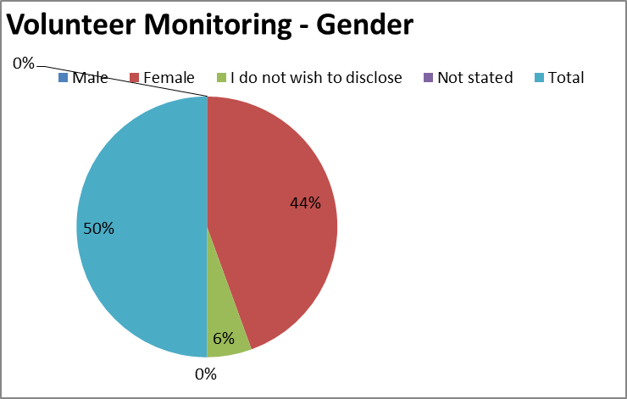
Gender
 | Recruited
Male | 0
Female | 8
I do not wish to disclose | 1
Not stated | 0
Total | 9

Age |  |  | 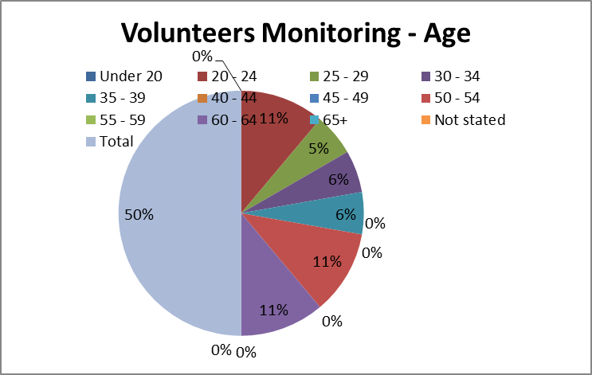
 | Recruited
Under 20 | 0
20 - 24 | 2
25 - 29 | 1
30 - 34 | 1
35 - 39 | 1
40 - 44 | 0
45 - 49 | 0
50 - 54 | 2
55 - 59 | 0
60 - 64 | 2
65+ | 0
Not stated | 0
Total | 9
Ethnic Origin
 | Recruited
WHITE - British | 2
WHITE - Irish | 0
WHITE - Any other white background | 0
ASIAN or ASIAN BRITISH - Indian | 1
ASIAN or ASIAN BRITISH - Pakistani | 2
ASIAN or ASIAN BRITISH - Bangladeshi | 0
ASIAN or ASIAN BRITISH - Any other Asian background | 0
BLACK or BLACK BRITISH - Caribbean | 2
BLACK or BLACK BRITISH - African | 0
BLACK or BLACK BRITISH - Any other black background | 0
MIXED - White & Black Caribbean | 0
MIXED - White & Black African | 0
MIXED - White & Asian | 0
MIXED - any other mixed background | 0
OTHER ETHNIC GROUP - Chinese | 0
OTHER ETHNIC GROUP - Any other ethnic group | 0
I do not wish to disclose my ethnic origin | 2
Not stated | 0
Total | 9

Disability
 | Recruited
No | 7
Yes | 1
I do not wish to disclose whether or not I have a disability | 1
Not stated | 0
Total | 9
Guaranteed interview scheme
No | 5
Yes | 1
Not stated | 3
Total | 9
Disability Description
Physical impairment | 0
Sensory impairment | 0
Mental health condition | 0
Learning disability/difficulty | 0
Long-standing illness | 1
Other | 0
 | 3
Not stated | 5
Total | 9

Sexual Orientation
 | Recruited
Bisexual | 0
Gay | 0
Heterosexual or Straight | 7
Lesbian | 0
I do not wish to disclose my sexual orientation | 2
Gay or Lesbian | 0
Other sexual orientation not listed | 0
Undecided | 0
Not stated | 0
Transgender | 0
Total | 9

Marital Status |  |  |  | 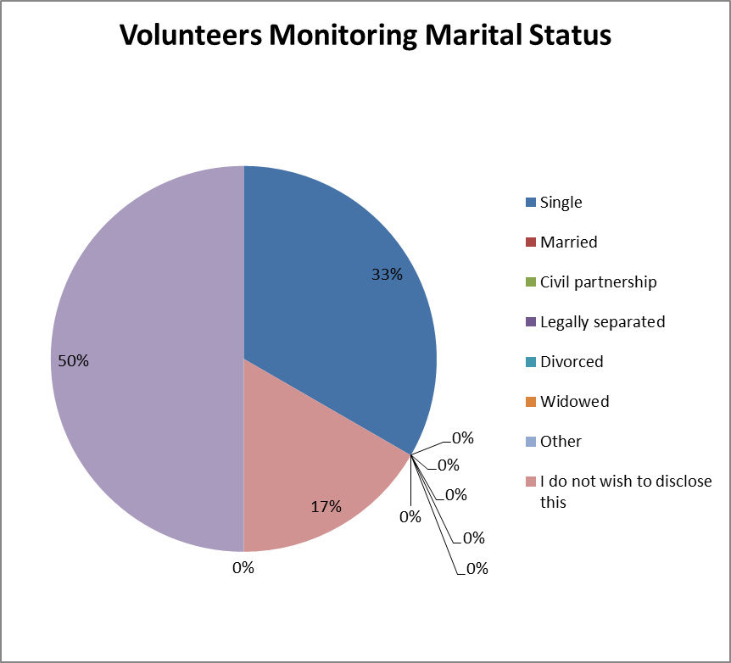
 |  | Recruited
Single |  | 6
Married |  | 0
Civil partnership |  | 0
Legally separated |  | 0
Divorced |  | 0
Widowed |  | 0
Other |  | 0
I do not wish to disclose this |  | 3
Not stated |  | 0
Total |  | 9

Religion |  | 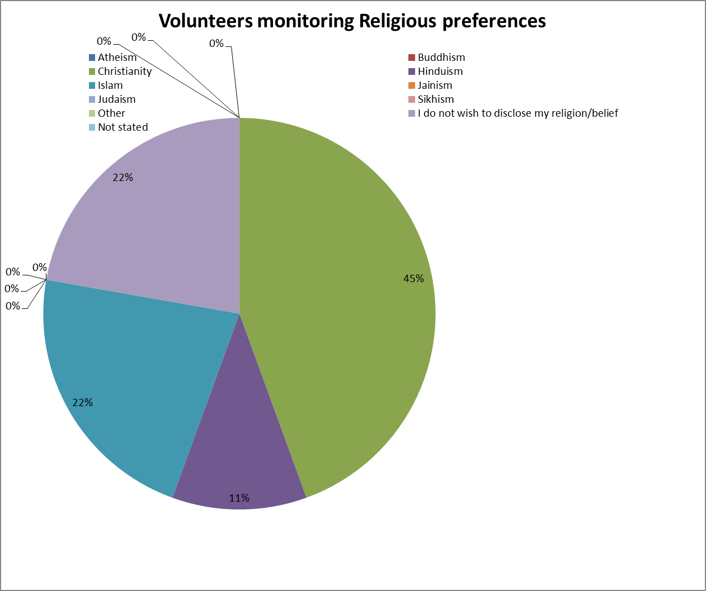
 | Recruited
Atheism | 0
Buddhism | 0
Christianity | 4
Hinduism | 1
Islam | 2
Jainism | 0
Judaism | 0
Sikhism | 0
Other | 0
I do not wish to disclose my religion/belief | 2
Not stated | 0
Total | 9

Summary provided by Widening Participation Team:

There has been significant changes in the volunteer recruitment process in recent times.

Challenges to volunteer recruitment

- Teams have significant staffing pressures that have a direct impact on whether they have a volunteer, therefore those teams who wish to and can support a volunteer are fewer.

- A number of safeguarding concerns were identified in 2017/8 and have/are being dealt with in terms of how contact is maintained, how volunteers are supervised once recruited

- The nature of the Trust spread across 40 + sites presents a challenge to keeping in touch with volunteers once they have completed the recruitment phase.

- The application process, DBS check and eLearning and OH checks has been identified particularly in recent cases of service users wishing to volunteer as making the process itself difficult to navigate.

- The WPV team support applicants with forms and eLearning etc. and specific team access to many sites.

- Areas (particularly inpatient teams) that are also short staffed or take a number of students do not always have capacity to identify a supervisor and take volunteers as well.

- A number of services and partnerships such as Park lane Gardens, Bita Pathways, Express signs are no longer internal options but external pathways.

Solution focussed steps within volunteer recruitment and retention

- Where teams take volunteers. WPV work with Team managers to identify a local Volunteer supervisor as per policy, to appreciate, nurture and develop their volunteers

- WPV assist managers draw up a suitable role profile, and proactively support the recruitment, help and tutoring with eLearning as capacity allows.

- Volunteer inductions are managed locally and Trust ID’S, and DBS information is logged in ESR.

- Site specific Trust ID’s. Volunteers can report to more than one supervisor but do not have access to all areas.

- Training and Development days with a variety of formats and updates to suit different learning styles for volunteers are in development for 2019- 2020.

- Areas that are fully staffed and have a successful track record with volunteers are always more willing to take on other volunteers.

WPV Resource is committed to developing safe pathways and mechanisms that support managers and all who wish to volunteer internally.

In terms of overall numbers the analysis of the data is particularly hard to evaluate as there are a significant number who do not complete the Volunteer recruitment process.

APPENDIX 2
Birmingham and Solihull Mental Health NHS Foundation Trust
Service User Data Report
January 2018 – Dec 2018
If you require this in a different format e.g. larger print, Braille, different languages or audio tape, please contact the HR Department on 0121 301 1257 or email HR.support@bsmhft.nhs.uk

TABLE 1: Patients by Gender
Gender | % of Gender
Female | 56.16%
Male | 43.80%
Not Known | 0.01%
Non binary | 0.02%
Grand Total | 100%

TABLE 2: Patients by Age
Age | % by Age
under 15 | 2.50%
16 to 17 | 2.15%
18 to 19 | 2.54%
20 to 24 | 7.28%
25 to 29 | 10.29%
30 to 44 | 27.32%
45 to 59 | 22.64%
60 to 64 | 4.76%
65 to 74 | 6.92%
75 to 84 | 7.75%
85 to 89 | 3.56%
90 and over | 2.29%
Grand Total | 100.00%

TABLE 3: Patients by Ethnicity
Ethnic Groups | % by Ethnicity
Any other Ethnic Group | 2.64%
Asian/Asian British: Bangladeshi | 1.10%
Asian/Asian British: Chinese | 0.29%
Asian/Asian British: Indian | 3.34%
Asian/Asian British: Other Asian | 1.67%
Asian/Asian British: Pakistani | 7.72%
Black/African/Caribbean/Black British: African | 1.26%
Black/African/Caribbean/Black British: Caribbean | 4.73%
Black/African/Caribbean/Black British: Other Black | 0.61%
Mixed/multiple ethnic group: White and Asian | 0.43%
Mixed/multiple ethnic group: White and Black African | 0.19%
Mixed/multiple ethnic group: White and Black Caribbean | 1.66%
Other ethnic group: Arab | 0.27%
Other Mixed | 0.88%
White: English/Welsh/Scottish/Northern Irish/British | 62.62%
White: Gypsy or Irish Traveller | 0.04%
White: Irish | 1.70%
White: Other White | 1.94%
Not Known | 6.90%
Grand Total | 100.00%

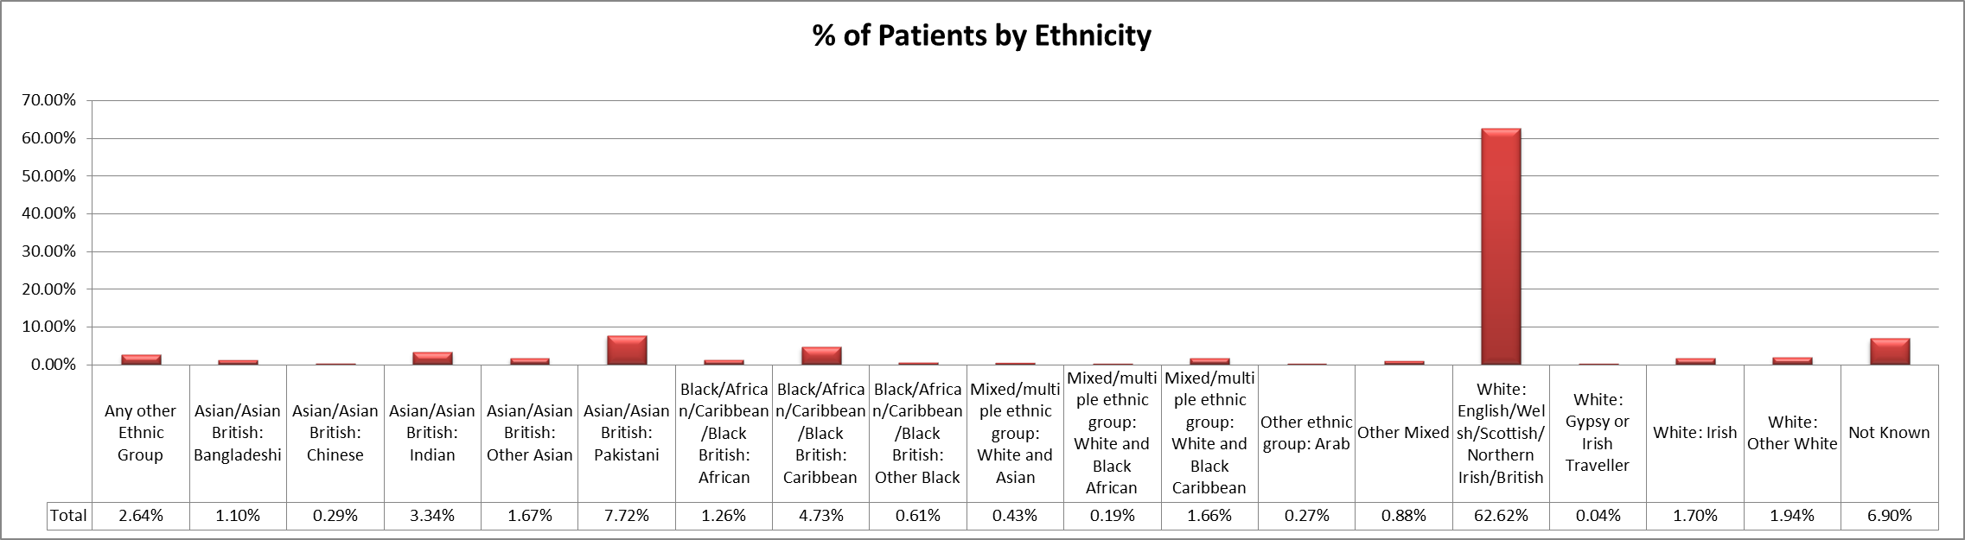

TABLE 4: Patients by Disability
Disability | % by Disability
No | 94.98%
Yes | 5.02%
Grand Total | 100.00%

TABLE 5: Patients by Disability – Hearing and Sigh
Disability - Hearing | % by  Disability- Hearing | Disability- Sight | % by  Disability-  Sight
No | 16.54% | No | 16.39%
Not Recorded | 81.84% | Not Recorded | 82.11%
Yes | 1.62% | Yes | 1.50%
Grand Total | 100.00% |  | 100.00%

TABLE 6: Patients by Disability – Mobility and Learning Disability
Disability - Mobility | % by  Disability- Mobility | Disability -Learning  Disability | % by Disability -  Learning  Disability
No | 14.13% | No | 14.23%
Not Recorded | 81.79% | Not Recorded | 82.02%
Yes | 4.07% | Yes | 3.75%
Grand Total | 100.00% |  | 100.00%

TABLE 7: Patients by Marital Status
Marital Status | % by Marital Status
Co-Habitee | 1.70%
Common Law/Cohabit | 0.04%
Divorced / Civil Partnership dissolved | 3.14%
Married/Civil Partner | 17.02%
Separated | 1.80%
Single | 30.50%
Widowed | 4.99%
Not Known | 40.81%
Grand Total | 100.00%

TABLE 8: Patients by sexual Orientation
Sexual Orientation | % by Sexual Orientation
Bi-sexual | 0.21%
Gay/Lesbian | 0.30%
Heterosexual | 12.14%
Other | 0.12%
Not Known | 87.23%
Grand Total | 100.00%

TABLE 9: Patients by Religion
Religion | % by Religion
Agnostic | 0.81%
Atheist | 1.20%
Baha'i | 0.01%
Baptist | 0.65%
Born Again Christian | 0.04%
Buddhist | 0.29%
Christadelphian | 0.09%
Christian | 21.04%
Christian Fellowship | 0.01%
Christian Science | 0.01%
Christian Scientist | 0.01%
Church of England | 25.82%
Church of God | 0.04%
Church of God of Prophecy | 0.15%
Church of Ireland | 0.05%
Church of Scotland | 0.13%
Church of Wales | 0.03%
Greek Orthodox | 0.15%
Hindu | 1.23%
Humanist | 0.03%
Jain | 0.01%
Jehovah's Witness | 0.64%
Jewish | 0.27%
Methodist | 0.87%
Mormon | 0.09%
Muslim | 16.25%
Not Religious | 12.97%
Orthodox | 0.05%
Orthodox Jew | 0.02%
Other Religion (not on list) | 1.26%
Pagan | 0.13%
Pentecostal | 0.08%
Pentecostalist / Pentecostal Christian | 0.28%
Protestant | 0.13%
Quaker (Religious Society of Friends) | 0.03%
Rastafari | 0.30%
Rastafarian | 0.07%
Reform Jew | 0.01%
Roman Catholic | 11.94%
Salvation Army Member | 0.01%
Seventh Day Adventist | 0.13%
Shi'ite Muslim | 0.02%
Sikh | 2.34%
Spiritualist | 0.19%
Sunni Muslim | 0.06%
United Reform | 0.04%
United Reformed Church | 0.03%
Welsh Congregational | 0.01%
(blank) | 0.00%
Grand Total | 100.00%

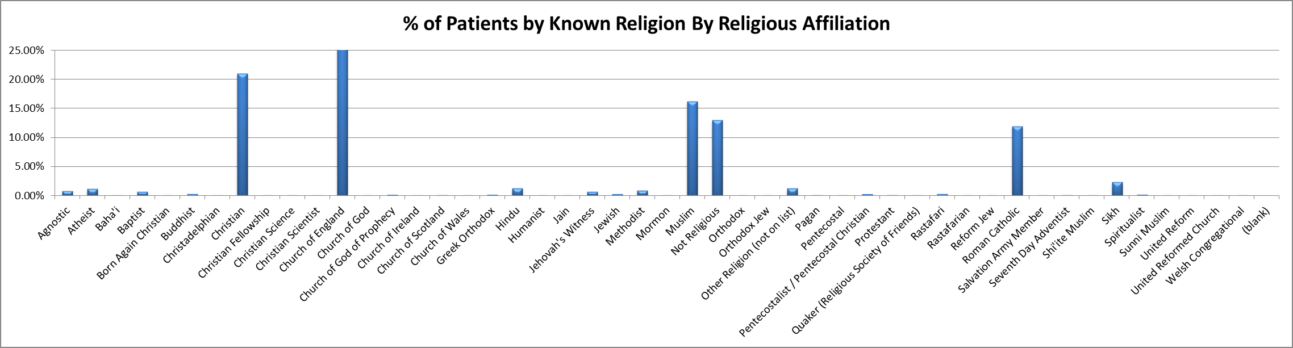

Patients who have no known religion (77%) have been removed from the % of patients by known religion by religious affiliation chart above.
The IAPT Service are only included in the Gender, Age Band and Disability charts as we are unable to provide a detailed breakdown.

