Item 9

BIRMINGHAM AND SOLIHULL MENTAL HEALTH NHS FOUNDATION TRUST

INTEGRATED QUALITY COMMITTEE TO BE HELD ON WEDNESDAY 20 APRIL 2016

EQUALITY AND DIVERSITY ANNUAL REPORT
As Required by the Equality Act and The Public Sector Equality Duty
ACTION:
IQC is asked to note the contents of this report and progress made in 2015
Executive Summary

2015 was an extremely very busy and eventful year for the trust in relation to the equality, diversity and inclusion agenda. The initiatives and projects launched in 2014 are starting to show some very positive results on some of the objectives identified by the Equality and Diversity Strategy.

Most importantly, after extensive consultation the trust now has a Board agreed Equality and Diversity Strategy for 2016 to 2020 as required by the Public Sector Equality Duty.

Achievements in 2015/16
- Successfully delivering and evaluating the Cultural Ambassadors project
- Delivery of training and implementation of the Trust Mediation Pool
- Delivery of Data of Verification Exercise 2015
- Delivery of Diversity Week 2015
- Completion and submission to Stonewall’s Workplace Equality Index
- Establishment of all three Staff Networks:
  - LGBT – 40 members of staff taking part in Birmingham Pride
  - Black and Minority Ethnic
  - Disability Staff Network
  - Workshop on dyslexia and establishing a dyslexia working group
  - Re-launch of staff Bullying and Harassment Advisors
- Delivery of Inclusion Masterclass workshops x 3
- Development and delivery of Trust wide events on:
  - Bullying and Harassment
  - Equal Opportunity
  - Managing Conflict
- Delivery of 2015 Black History Month Events
  - Race, Religion and LGBT debate
  - Black History Month Conference
- Implementation Equality Analysis Guidance and Assessment Tools
- Various team workshops and training sessions on equality, diversity and managing conflict
- Publication of annual Workforce Equality Data report (See Appendix 1)
- Publication of annual Service User Data report (See Appendix 2)
- Participated in National Time to Talk day – Looking at Staff Mental Health
- Signed up to NHS England Learning Disability Pledges
- Shortlisted for the Healthcare People Management Association (HPMA) Awards in two different categories for the Cultural Ambassadors (Partnership Working) project and the Mediation Pool (Courage to Manage).

Workforce Equality Data – Appendix 1

The Public Sector Equality Duty requires that we gather, analyse and publish equality data an all of the Personal Protected Characteristics on our workforce and service users. Analysis of the workforce data continues to show improvements in the following areas:
- A general improvement in the quality and completeness of the information held in ESR
- An increase in the number of staff under 25 years old due to the widening participation programme
- Improvement in the appointment of BME staff in some categories across the workforce

However, there remains a number of key challenges for the trust such as:

- The retention of BME staff after they have been appointed
- The progression and development of BME staff at certain management bands
- We need to continue to improve our data collection in order to carry out effective analysis of our workforce in order to meet both the Public Sector Equality Duty and the NHS Race Equality Standard
- Continue to address the high proportions of “Not Stated” or “Unknowns” across all of the protected characteristics

By addressing these issues we will be working towards delivery of our Equality Objectives identified through the Equality Delivery System and the Equality Thermometer.

Service User Data – Appendix 2

Analysis of the 2015 service user data shows that we have seen over 58,000 patients in the twelve months from January to December 2014, and seen an increase of 2419 on the 2014 number. The highest age group is the 30 to 44 year group at 24.38%. In relation to Gender 52.72% of our users were female and 47.25 were male. Almost 26% of service users are from BME background, with Asian and Asian and British Pakistani being the highest BME user at 6.5%, followed by Black African Caribbean and Black British African at 4.4%.

The most challenging areas however are as follows:

- There is no information collected on Transgender
- There are still high areas on “not known” particularly in the disability category when broken down into different disability categories such as:
  - Hearing Impairment – 80% Not Known
  - Visual Impairment – 80% Not Known
  - Mobility – 81% Not Known
  - Autistic Spectrum Disorder – 88% Not Known
  - Learning Disability – 81% Not Known
  - Religion and Belief – 59% Not Known
  - Ethnicity – 14.6% Not Known

Our ability to collect equality data must remain a priority and focus will be placed on operational areas in order to address this issue. It will also be vital that there are appropriate information systems to record the information such as appropriate fields to input data such as transgender.

Data Verification Exercise – Appendix 3

The annual data verification exercise continues to demonstrate improvement on the data we collect on the workforce. This continues to be delivered through series or communication methods allowing staff to update their personal information and to provide information where they did not previously disclose. The exercise went a long way to improve the overall quality of information and the full report can be seen at Appendix 3.

Black History Month Events - Appendix 4

Our trust, in partnership with the Royal College of Nursing (RCN), once again delivered the regional Black History Month conference “Unexpected Connexions” on 20 November 2015. The aim of the conference was to:
- The deliver a number of outputs that would act as legacy outcomes that would continue the conversation on race diversity
- Connecting diversity to service delivery
- Create a learning environment where delegates can have a challenging conversation
- Raise awareness or current BME challenges in the NHS
- Attract a different demographic of delegates to previous years
- A recognition of achievements of BME staff in the trust

Speakers included Paul Deemer - Head of Equality and Diversity, NHS Employers, Wendy Irwin - Head of Equality and Diversity, RCN, and Yasmin Khan MBE, HMRC.

The event was attended by over 120 delegates and at 4pm there were still over 100 people in the room. The award for outstanding achievements went to Faheem Hussain for his contribution for supporting service users and the improvement to service.

The outputs from the day are still on display in Uffculme we will be continuing the partnership for the delivery of the 2016 conference. A full evaluation of the day can be found at Appendix 4.

Cultural Ambassadors (CA) Project – Cultural Ambassadors Evaluation

We started the Cultural Ambassadors in the trust in October 2014 for a twelve month trial. The project has now been evaluated by Worcester University and the summary report is at Appendix 5.

The project has proved to be successful and we are the only Trust to have successfully implemented it out of the four original Trusts. Although there is little evidence to show the correlation between CAs and BME Staff entering the employee disciplinary process there is some anecdotal evidence to say that BME staff have had a positive experience when CAs are present. The initial findings are as follows:

- HR managers told us that investigating managers and chairs of disciplinary panels are different when Cultural Ambassadors are present
- Sanctions awarded to BME staff have been less severe in 2015 when compared to sanctions in 2014
- There has been a reduction in BME staff moving from the initial investigation to disciplinary action in 2015 compared to 2014

The CAs initiative I now fully embedded into the employee relations process with the following additions:
- The CA will be appointed much earlier in the process to support the commissioning manager in deciding if there are any cultural bias issues to be considered prior to cases being commissioned for investigation
- All supporting administrative letters will note the appointment of a CA when this is relevant and supporting information about their role will be provided to the staff member
- The equality and diversity lead will continue to provide professional and supervisory support to the CAs and the employee relations team will have the operational and implementation responsibility

The RCN has announced that they will be launching the Cultural Ambassadors nationally as a result on this project during 2016.

Mediation Pool

The trust pool of twelve mediators was launched in April 2015 after their six day accredited course. Early indication is that this is proving to be having an impact on the employee relation case and the experience of staff that enter the service. Since inception there have been 18 mediation cases with 16 having reached a successful conclusion and an 88% success rate. Although BME staff remain overrepresented in the employee relations process there has been an increase to resolve conflict through the informal process in the last 12 months.

In the period from April 2015 to August 2015 the number of investigations being commissioned dropped from 32 to 26 when compared to the previous year. The total number of formal bullying and harassment for 2015 was 13 compared to 24 in 2014.

The feedback received from staff who have used the service have been very positive of their experience and for being provided the opportunity and space to resolve their issue without entering the employee relations process formally. There has also been high praise for the quality of service from the mediators. The service is now firmly embedded in the employee relation process and policy.

Equality and Diversity Training

As well as our equality and diversity ELearning programme, training has been delivered in a number of different ways and forums:

- Various team building workshops or awareness sessions
- Various Trust wide workshops with focus on specific equality issues
- Regular Knowledge in Practice sessions for those who are unable to pass their ELearning

Staff Networks

BaME Staff Network: This group is now beginning to function well with a chair and vice chair. Although it is a consistent challenge to get staff to attend. Therefore, staff will now be given the option to teleconference in and meeting will be held at different venues.

The group is now looking at a programme of work to include:

- Support the undertaking of Equality Analysis
- Running events May Diversity Week
- Black History Month event in October
- Improved engagement with ProActive Partnership

LGBT Staff Group: This group is now well established with its own chair, committee and establishing a steering group to progress its programme of work. (See Appendix 6). The group has a well thought out plan of events and activities and the steering group will be looking to deliver the activities of the work plan. .

Disability Staff Group: The Disability staff network is now established, however yet to establish a regular chair. The network is keen to establish so work projects particularly to do more to support staff with mental health. Time to Talk day was a big success for the trust and identified the need to have “time to talk champions” across the trust.
BOARD DIRECTOR SPONSOR: Dr Hilary Grant, executive medical director

APPENDIX:
Appendix 1 – Workforce Data Report
Appendix 2 – Service User Equality Data Report
Appendix 3 – Data Verification Exercise Report
Appendix 4 – Black History Month Event Evaluation
Appendix 5 – Cultural Ambassadors Evaluation Report

PREVIOUSLY DISCUSSED: none

Appendix 1

Birmingham and Solihull Mental Health Foundation Trust
Equality and Diversity Workforce Data Report
January 2015 to December 2015

If you require this in a different format e.g. larger print, Braille, different languages or audio tape, please contact the HR Department on 0121 301 1257 or email HR.support@bsmhft.nhs.uk
- Background

  - The Equality Act 2010 places a Public Sector Equality Duty on the Trust to ensure that we work towards:

- The elimination of discrimination
- The advancement of equality
- The promotion of equal opportunity

  - In addition there are a number of national and local drives which will influence our strategic decisions and the manner that we carry out our day to day role. These include:
- The NHS Constitution
- The CQC Essential Requirements
- The NHS Staff Survey
- The NHS Workforce Race Equality Standards
- The NHS Equality Delivery System (EDS2)

  - All of the above provides a national context and as a Trust looking to provide the best working environment for our staff in order for them to deliver a quality service to the patients and carers they serve, it is vital that we are able to identify our priorities in partnership with our local stakeholder, staff, service users and carers.

1.4 As a Trust we are fully committed to the equality, diversity and inclusion agenda and we have a clear understanding of our responsibilities from the Public Sector Equality Duty. We strive to deliver a service that is fair and equitable to the varied and diverse population we serve and to create a safe and inclusive working environment where people from all sectors of the community can come to work and feel valued, provided with the support and development required so that they can reach their full potential.

- Context

  - This report is to publish our Equality Data from January 2015 to December 2015 as required by the Public Sector Equality Duty. Analysis of the data will assist the Trust in undertaken a number of initiatives for 2016/17 and deliver on the requirements of the Workforce Race Equality Standards. These action will include initiatives to:
- Improve the quality of the data
- The planning, development and progression of staff from underrepresented groups
- The development of leadership and management training
- Improving the confidence and experience of staff when involved in the employee relations process
- Creating safe environments where staffs from all protected characteristics are able to express their concerns without fear of recrimination.
- Maintain a safe working environment for staff
- Improve the day to day service that we deliver

Table 1: Workforce Age Profile

 | 2015
Age Range | Headcount | 2015 %Headcount | 2014 %Headcount | 2013 % Headcount | 2012 % Headcount
<20 | 20 | 0.5% | 0.5% | 0.1% | 0.1%
20-29 | 615 | 14.7% | 14.7% | 14.3% | 13.1%
30-39 | 1,023 | 24.5% | 24.5% | 25.7% | 25.0%
40-49 | 1,211 | 29.0% | 29.0% | 30.8% | 32.7%
50-59 | 1,076 | 25.7% | 25.7% | 23.8% | 23.6%
60-64 | 186 | 4.4% | 4.4% | 4.2% | 4.5%
>65 | 49 | 1.2% | 1.2% | 1.2% | 1.0%
Grand Total | 4,180 | 100.0% | 100% | 100.0% | 100.0%

Analysis of the above table shows that in relation to age the only significant difference to our age profile is in the less than 20 age category. All other areas have remained the same as 2014

Table 2: Workforce Disability Profile 2014:
 | 2015
Headcount | Headcount | 2015 %Headcount | 2014 %Headcount |  | 2013 % Headcount | 2012 % Headcount
No | 3,896 | 93.2% | 2850 | 93.2% | 61.4% | 56.6%
Not Declared/undefined | 129 | 3.1% | 1,235 | 3.1% | 35.6% | 40.8%
Yes | 155 | 3.7% | 152 | 3.7% | 3.0% | 2.6%
Grand Total | 4,180 | 100.0% | 100.0% |  | 100.0% | 100.00%

In table 2 above there has been a significant difference in the not declared or undefined categories, from 40% in 2012 to 3.1% in 2015. The number of staff declaring No disability has also improved from 56.6% in 2012 to 93% in 2015 again a significant change. Staff declaring a disability has improved from 2.6% to 3.7% from 2012 to 2015. This could be an illustration of the impact that undertaking the data verification exercise is making on our data collection.

Table 3: Religion and Belief Profile:

 | 2015
Religion | Headcount | 2015 %Headcount | 2014 %Headcount |  | 2013 % Headcount | 2012 % Headcount
Atheism | 349 | 8.3% | 319 | 7.5% | 6.3% | 4.6%
Buddhism | 17 | 0.4% | 12 | 0.3% | 0.3% | 0.3%
Christianity | 1,670 | 40.0% | 1,667 | 39.3% | 36.2% | 33.8%
Hinduism | 75 | 1.8% | 69 | 1.6% | 1.4% | 1.3%
Islam | 204 | 4.9% | 167 | 3.9% | 3.7% | 3.1%
Jainism | 0 | 0.0% | 1 | 0.0% | 0.1% | 0.1%
Judaism | 9 | 0.2% | 7 | 0.2% | 0.2% | 0.2%
Other | 254 | 6.1% | 250 | 5.9% | 5.3% | 4.5%
Sikhism | 87 | 2.1% | 82 | 1.9% | 1.7% | 1.5%
I do not wish to disclose my religion/belief | 1,482 | 35.5% | 634 | 15.0% | 7.4% | 7.3%
Not Declared/Undefined | 33 | 0.8% | 1,029 | 24.3% | 37.5% | 43.5%
Grand Total | 4,180 | 100.0% | 100.0% |  | 100.0% | 100.00%
Table 3 above shows very little change in relation to the staff demographics on religion and belief. However, more staff is choosing not to disclose their religion or belief than in previous years.

Table 4: Gender (Sex) Profile:

 | 2015
Gender | Headcount | 2015 %Headcount | 2014 %Headcount | 2013 % Headcount | 2012 % Headcount
Female | 2,962 | 70.9% | 71.7% | 70.0% | 70.4%
Male | 1,218 | 29.1% | 29.7% | 30.0% | 29.6%
Grand Total | 4,180 | 100.0% | 101.4% | 100.0% | 100.0%

Table 4 above shows that there is very little change in relation to the gender make-up of the Trust up a 70% female and 30% male split.

Table 5: Sexual Orientation Profile
 | 2015
Sexual Orientation | Headcount | 2015 %Headcount | 2014 %Headcount | 2013 % Headcount | 2012 % Headcount
Bisexual | 21 | 0.5% | 0.4% | 0.4% | 0.3%
Gay | 35 | 0.8% | 0.8% | 0.8% | 0.7%
Heterosexual | 2,589 | 61.9% | 59.1% | 51.4% | 45.2%
Lesbian | 26 | 0.6% | 0.6% | 0.4% | 0.4%
I do not wish to disclose my sexual orientation | 1,477 | 35.3% | 13.1% | 6.2% | 6.2%
Undisclosed | 32 | 0.8% | 27.3% | 40.8% | 47.3%
Grand Total | 4,180 | 100.0% | 101.4% | 100.0% | 100.0%

Table 5 above on Sexual Orientation possibly as a result of the data verification exercise many staff have moved from a position of undisclosed to 40.8% in
2014 to .8% in 2015) “I do not wish to disclose” (13.1% in 2014 to 35.3% in 2015). However, the number of staff who disclose the sexual orientation shows a
continuous improvement.

Table 6: Ethnicity Profile
Ethnicity |  | Trust Profile 2009 | Trust Profile 2010 | Trust Profile 2011 | Trust Profile 2012 | Trust Profile 2013 | Trust Profile 2014 | Trust Profile 2015 | Birmingham Population | Solihull Population | **Birmingham & Solihull Population
Asian or British Asian | Bangladeshi | 0.5% | 0.5% | 0.6% | 0.5% | 0.5% | 0.6% | 0.6% | 3.0% | 0.3% | 2.6%
 | Indian | 6.0% | 5.9% | 6.3% | 6.7% | 6.2% | 6.4% | 6.3% | 6.0% | 3.4% | 5.6%
 | Other Asian | 1.4% | 1.3% | 1.3% | 1.2% | 1.3% | 1.3% | 1.6% | 2.9% | 0.7% | 2.6%
 | Pakistani | 2.5% | 2.5% | 2.7% | 2.5% | 2.9% | 3.1% | 3.7% | 13.5% | 1.7% | 11.6%
Black or Black British | Black African | 6.6% | 6.3% | 6.7% | 6.8% | 7.0% | 7.2% | 7.4% | 2.8% | 0.4% | 2.4%
 | Black Caribbean | 9.1% | 9.2% | 8.9% | 8.7% | 8.9% | 9.0% | 8.8% | 4.4% | 0.9% | 3.9%
 | Other Black | 0.9% | 1.0% | 1.0% | 1.0% | 1.0% | 1.1% | 1.0% | 1.7% | 0.2% | 1.5%
Chinese | Chinese | 0.2% | 0.3% | 0.3% | 0.3% | 0.3% | 0.4% | 0.4% | 1.2% | 0.4% | 1.1%
Mixed | Other Mixed | 0.3% | 0.4% | 0.4% | 0.4% | 0.5% | 0.6% | 0.6% | 0.8% | 0.3% | 0.7%
 | White & Asian | 0.4% | 0.4% | 0.5% | 0.5% | 0.5% | 0.5% | 0.5% | 1.0% | 0.6% | 1.0%
 | White & Black African | 0.4% | 0.5% | 0.5% | 0.5% | 0.4% | 0.4% | 0.5% | 0.3% | 0.1% | 0.3%
 | White & Black Caribbean | 1.2% | 1.2% | 1.3% | 1.4% | 1.6% | 1.9% | 2.1% | 2.3% | 1.2% | 2.1%
Other Ethnic Group | Other Ethnic Group | 1.2% | 1.1% | 1.0% | 1.0% | 0.9% | 1.0% | 0.9% | 2.0% | 1.0% | 2.0%
Undefined | Not Stated | 8.6% | 8.1% | 7.3% | 7.2% | 6.8% | 5.2% | 6.6% | 0.0% | 0.0% | 0.0%
White | British | 54.5% | 55.3% | 55.2% | 55.3% | 55.3% | 55.2% | 53.7% | 53.1% | 85.8% | 58.4%
 | Gypsy or Irish Traveller | 0.0% | 0.0% | 0.0% | 0.0% | 0.0% | 0.0% | 0.0% | 0.0% | 0.0% | 0.0%
 | Irish | 3.9% | 3.6% | 3.5% | 3.3% | 2.9% | 2.8% | 2.4% | 2.1% | 1.9% | 2.0%
 | Other White | 2.4% | 2.5% | 2.5% | 2.9% | 2.9% | 3.2% | 3.1% | 2.7% | 1.4% | 2.5%
Grand Total |  | 100.0% | 100.0% | 100.0% | 100.0% | 100.0% | 100.0% | 100.0% | 100.0% | 100.0% | 100.0%

Table 5 shows that White British continues to be the most represented group in the Trust matching the population of Birmingham at 53%. The data also shows a
trend of continuous improvement in relation to Black African from 6% in 2009 to 7.7% in 2015 almost 5% higher that the Black African population of Birmingham
at 2.8%. The number of Irish staff has continued on a downward trend from 3.9% in 2009 to 2.4% in 2015, however still above the Birmingham population of 2.1%.
Table 7: Recruitment Activity by Age
 | 2015 |  |  |  | 2014 |  |  |  | 2013
Age Range | % of Applications Received | % of shortlisted Applicants | % of Applicants Appointed | Trust Profile | % of Applications Received | % of shortlisted Applicants | % of Applicants Appointed | Trust Profile | % of Applications Received | % of shortlisted Applicants | % of Applicants Appointed | Trust Profile
<20 | 2.0% | 0.9% | 0.7% | 0.5% | 2.3% | 1.2% | 1.6% | 0.5% | 3.2% | 1.3% | 1.0% | 0.1%
20-29 | 42.1% | 33.4% | 35.3% | 14.7% | 41.7% | 32.5% | 28.1% | 14.3% | 43.7% | 36.2% | 43.0% | 14.3%
30-39 | 26.9% | 29.0% | 29.0% | 24.5% | 27.0% | 29.6% | 29.7% | 25.2% | 25.6% | 28.3% | 29.5% | 25.7%
40-49 | 18.1% | 23.3% | 23.0% | 29.0% | 19.0% | 24.0% | 32.8% | 29.9% | 18.5% | 22.3% | 16.4% | 30.8%
50-59 | 9.9% | 12.2% | 11.0% | 25.7% | 9.2% | 11.9% | 7.9% | 24.6% | 8.5% | 11.2% | 9.5% | 23.8%
60-64 | 0.9% | 0.9% | 0.4% | 4.4% | 0.7% | 0.8% | 0.0% | 4.2% | 0.4% | 0.6% | 0.5% | 4.2%
>65 | 0.1% | 0.2% | 0.4% | 1.2% | 0.0% | 0.0% | 0.0% | 1.3% | 0.0% | 0.0% | 0.2% | 1.2%
Total | 100% | 100% | 100% | 100.0% | 100.00% | 100.00% | 100.00% | 100.0% | 100.0% | 100.0% | 100.0% | 100.0%

Table 8: Recruitment Activity by Gender (Sex)
 | 2015 |  |  |  |  | 2014 |  |  |  |  |  |  |  | 2013
Gender | % of Applications Received | % of Shortlisted Applications | % of Applicants Appointed | Trust Profile |  | % of Applications Received | % of Shortlisted Applications | % of Applicants Appointed |  | Trust Profile |  | % of Applications Received |  | % of shortlisted Applicants |  |  | % of Applicants Appointed | Trust Profile
Female | 71.7% | 73.1% | 74.6% | 70.9% |  | 72.0% | 73.0% | 68.8% |  | 70.7% |  | 70.9% |  | 72.1% |  |  | 70.0% | 70.0%
Male | 27.8% | 26.5% | 25.4% | 29.1% |  | 28.0% | 27.0% | 31.2% |  | 29.3% |  | 29.1% |  | 27.9% |  |  | 30.0% | 30.0%
Total | 0.5% | 0.4% | 0.0% | 100.0% |  | 100.0% | 100.0% | 100.0% |  | 100.0% |  | 100.0% |  | 100.0% |  |  | 100.0% | 100.0%

Table 9: Recruitment Activity by Disability

 | 2015 |  |  |  |  | 2014 |  |  |  |  |  |  | 2013
Disability | % of Applications Received | % of Shortlisted Applications | % of Applicants Appointed | Trust Profile |  | % of Applications Received |  | % of Shortlisted Applications | % of Applicants Appointed |  | Trust Profile |  | % of Applications Received |  |  | % of Shortlisted Applications |  | % of Applicants Appointed |  | Trust Profile
Yes | 4.2% | 4.9% | 2.5% | 3.7% |  | 4.4% |  | 4.7% | 6.3% |  | 67.3% |  | 4.19% |  |  | 5.11% |  | 3.98% |  | 61.42%
No | 94.4% | 93.6% | 96.5% | 93.2% |  | 93.9% |  | 93.6% | 92.2% |  | 29.1% |  | 94.83% |  |  | 93.89% |  | 95.36% |  | 35.56%
Not Declared | 1.4% | 1.5% | 1.1% | 3.1% |  | 1.7% |  | 1.7% | 1.6% |  | 3.6% |  | 0.98% |  |  | 1.00% |  | 0.66% |  | 3.01%
Total | 100.0% | 100.0% | 100.0% | 100.0% |  | 100.0% |  | 100.0% | 100.0% |  | 100.0% |  | 100.0% |  |  | 100.0% |  | 100.0% |  | 100.0%

Table 10: Recruitment Activity by Sexual Orientation
 | 2015 |  |  |  |  | 2014 |  |  |  |  |  | 2013
Sexual Orientation | % of Applications Received | % of Shortlisted Applications | % of Applicants Appointed |  | Trust Profile | % of Applications Received | % of Shortlisted Applications |  | % of Applicants Appointed |  | Trust Profile | % of Applications Received | % of shortlisted Applicants | % of Applicants Appointed |  | Trust Profile
Lesbian | 0.6% | 0.5% | 1.1% |  | 0.6% | 0.5% | 0.7% |  | 1.6% |  | 0.42% | 0.6% | 0.5% | 0.7% |  | 0.4%
Gay | 1.2% | 1.4% | 2.1% |  | 0.8% | 1.0% | 1.1% |  | 0.0% |  | 0.78% | 0.9% | 0.9% | 1.0% |  | 0.8%
Bisexual | 1.0% | 1.0% | 0.7% |  | 0.5% | 1.1% | 0.9% |  | 1.6% |  | 58.32% | 1.0% | 0.9% | 0.3% |  | 51.4%
Heterosexual | 89.2% | 89.7% | 89.8% |  | 61.9% | 89.4% | 90.5% |  | 90.6% |  | 0.59% | 90.1% | 91.0% | 92.2% |  | 0.4%
Undisclosed | 8.0% | 7.4% | 6.4% |  | 0.8% | 8.0% | 6.8% |  | 6.3% |  | 39.9% | 7.4% | 6.7% | 5.8% |  | 47.0%
I do not wish to disclose my religion/belief |  |  |  |  | 35.3%
Total | 100.0% | 100.0% | 100.0% |  | 100.0% | 100.0% | 100.0% |  | 100.0% |  | 100.0% | 100% | 100% | 100% |  | 100%

Table 11 – Recruitment Activity by Religion or Belief

 | 2015 |  |  |  |  | 2014 |  |  |  | 2013
Religion | % of Applications Received | % of Shortlisted Applications | % of Applicants Appointed | Trust Profile | % of Applications Received |  | % of Shortlisted Applications | % of Applicants Appointed | Trust Profile | % of App-  lications  Received | % of shortlisted Applicants | % of Applicants Appointed | Trust Profile
Atheism | 10.3% | 11.0% | 13.8% | 8.3% | 9.4% |  | 9.6% | 15.6% | 7.5% | 7.7% | 8.7% | 15.9% | 6.3%
Buddhism | 0.5% | 0.4% | 0.4% | 0.4% | 0.6% |  | 0.5% | 0.0% | 0.3% | 0.4% | 0.4% | 1.0% | 0.3%
Christianity | 46.5% | 51.3% | 50.9% | 40.0% | 48.3% |  | 52.1% | 46.9% | 39.3% | 52.0% | 56.7% | 53.7% | 36.2%
Hinduism | 3.2% | 2.3% | 2.1% | 1.8% | 3.6% |  | 3.3% | 4.7% | 1.6% | 3.2% | 2.6% | 2.0% | 1.4%
Islam | 14.8% | 10.5% | 9.9% | 4.9% | 13.6% |  | 9.7% | 6.3% | 3.9% | 13.8% | 9.7% | 6.0% | 3.7%
Jainism | 0.0% | 0.0% | 0.0% | 0.0% | 0.0% |  | 0.0% | 0.0% | 0.0% | 0.0% | 0.0% | 0.0% | 0.1%
Judaism | 0.1% | 0.2% | 1.1% | 0.2% | 0.1% |  | 0.0% | 0.0% | 0.2% | 0.1% | 0.1% | 0.5% | 0.2%
Sikhism | 4.2% | 3.5% | 2.8% | 2.1% | 4.4% |  | 4.2% | 1.6% | 5.9% | 4.4% | 3.8% | 2.7% | 5.3%
Other | 9.9% | 10.7% | 12.7% | 6.1% | 10.0% |  | 10.7% | 10.9% | 1.9% | 10.4% | 10.8% | 10.9% | 1.7%
I do not wish to disclose my religion/belief |  |  |  | 35.5%
Undisclosed | 10.4% | 10.1% | 6.4% | 0.8% | 10.0% |  | 9.9% | 14.1% | 39.2% | 7.9% | 7.3% | 7.3% | 44.9%
Total | 100.0% | 100.0% | 100.0% | 100.0% | 100.0% |  | 100.0% | 100.0% | 100.0% | 100.00% | 100.00% | 100.00% | 100.00%

Table 12: Recruitment Activity by Ethnicity

2015 |  | 2014 |  |  |  | 2013
Ethnicity |  | Applied % | Shortlisted % | Appointed % | Trust Profile | Applied % | Shortlisted % | Appointed % | Trust Profile | % of Applications Received | % of Shortlisted Applications | % of Applicants Appointed | Trust Profile
Asian or Asian British | Bangladeshi | 2.4% | 1.6% | 1.8% | 0.6% | 1.9% | 1.4% | 1.6% | 0.61% | 2.0% | 1.2% | 0.5% | 0.53%
Asian or Asian British | Indian | 11.0% | 8.5% | 7.4% | 6.3% | 11.3% | 10.2% | 6.3% | 6.42% | 9.9% | 8.1% | 5.9% | 6.25%
Asian or Asian British | Other Asian | 1.6% | 1.5% | 1.1% | 1.6% | 1.7% | 1.7% | 1.6% | 1.35% | 1.8% | 1.5% | 1.3% | 1.26%
Asian or Asian British | Pakistani | 9.0% | 6.1% | 5.3% | 3.7% | 8.1% | 5.4% | 4.7% | 3.07% | 8.0% | 5.2% | 3.6% | 2.87%
Black or Black British | Black African | 11.0% | 13.2% | 9.5% | 7.4% | 11.6% | 13.0% | 7.8% | 7.17% | 14.0% | 16.9% | 12.0% | 7.00%
Black or Black British | Black Caribbean | 7.9% | 8.9% | 7.4% | 8.8% | 8.0% | 8.7% | 9.4% | 9.02% | 8.4% | 9.6% | 9.9% | 8.92%
Black or Black British | Other Black | 1.2% | 1.3% | 0.7% | 1.0% | 1.0% | 0.7% | 3.1% | 1.09% | 0.9% | 0.8% | 0.7% | 1.05%
Chinese | Chinese | 0.3% | 0.3% | 0.4% | 0.4% | 0.3% | 0.3% | 3.1% | 0.42% | 0.3% | 0.4% | 0.3% | 0.32%
Mixed | Other Mixed | 0.8% | 0.7% | 0.7% | 0.6% | 0.8% | 0.8% | 0.0% | 0.59% | 0.8% | 0.6% | 0.5% | 0.49%
Mixed | White & Asian | 0.7% | 0.6% | 1.1% | 0.5% | 0.6% | 0.6% | 1.6% | 0.50% | 0.6% | 0.5% | 1.0% | 0.51%
Mixed | White & Black African | 0.5% | 0.6% | 0.0% | 0.5% | 0.3% | 0.3% | 0.0% | 0.42% | 0.4% | 0.4% | 0.3% | 0.44%
Mixed | White & Black Caribbean | 2.6% | 2.6% | 3.9% | 2.1% | 2.5% | 2.8% | 0.0% | 1.91% | 2.5% | 2.8% | 3.3% | 1.63%
Other | Other Ethnic Group | 1.2% | 1.3% | 2.1% | 0.9% | 1.3% | 1.2% | 1.6% | 0.99% | 1.2% | 1.2% | 1.1% | 0.92%
Undefined | Not Stated | 3.1% | 2.5% | 0.7% | 6.6% | 3.2% | 2.7% | 1.6% | 5.22% | 4.9% | 2.6% | 1.8% | 6.76%
White | British | 42.8% | 46.7% | 53.7% | 53.7% | 43.3% | 46.4% | 53.1% | 55.2% | 41.0% | 44.6% | 55.0% | 55.25%
White | Gypsy or Irish Traveller |  |  |  | 0.0% | 0.0% | 0.0% | 0.0% | 0.0% | 0.0% | 0.0% | 0.0% | 0.0%
White | Irish | 0.9% | 1.0% | 1.1% | 2.4% | 1.1% | 1.4% | 1.6% | 2.83% | 0.8% | 1.0% | 0.5% | 2.89%
White | Other White | 3.0% | 2.4% | 3.2% | 3.1% | 3.1% | 2.3% | 3.1% | 3.16% | 2.6% | 2.5% | 2.3% | 2.92%
Total |  | 100.0% | 100.0% | 100.0% | 100.0% | 100.0% | 100.0% | 100.0% | 100.0% | 100.0% | 100.0% | 100.0% | 100.0%

Table 13: % staff working part time by age range
 | 2015 |  |  |  | 2014 |  |  |  | 2013
 | Headcount |  | %Headcount |  | Headcount |  | %Headcount |  | Headcount |  | %Headcount
Age Range | Full Time | Part Time | Full Time | Part Time | Full Time | Part Time | Full Time | Part Time | Full Time | Part Time | Full Time | Part Time
<20 | 17 | 3 | 0.5% | 0.3% | 19 | 3 | 0.6% | 0.3% | 2 | 1 | 0.1% | 0.1%
20-29 | 544 | 71 | 16.7% | 7.7% | 550 | 56 | 16.3% | 6.5% | 536 | 52 | 16.4% | 6.2%
30-39 | 765 | 258 | 23.5% | 28.0% | 815 | 252 | 24.1% | 29.3% | 810 | 248 | 24.8% | 29.4%
40-49 | 926 | 285 | 28.4% | 30.9% | 1,017 | 251 | 30.1% | 29.2% | 1,008 | 258 | 30.8% | 30.6%
50-59 | 862 | 214 | 26.5% | 23.2% | 836 | 205 | 24.7% | 23.9% | 779 | 199 | 23.8% | 23.6%
60-64 | 117 | 69 | 3.6% | 7.5% | 111 | 69 | 3.3% | 8.0% | 112 | 61 | 3.4% | 7.2%
>65 | 27 | 22 | 0.8% | 2.4% | 30 | 23 | 0.9% | 2.7% | 24 | 24 | 0.7% | 2.8%
Grand Total | 3258 | 922 | 100.0% | 100.0% | 3,378 | 859 | 100.0% | 100.0% | 3,271 | 843 | 100.0% | 100.0%

Table 14: % of staff working part time by Gender (sex)
 | 2015 |  |  |  | 2014 |  |  |  | 2013
 | Headcount |  | %Headcount |  | Headcount |  | %Headcount |  | Headcount |  | %Headcount
Gender | Full Time | Part Time | Full Time | Part Time | Full Time | Part Time | Full Time | Part Time | Full Time | Part Time | Full Time | Part Time
Female | 2166 | 796 | 66.5% | 86.3% | 2,250 | 747 | 66.6% | 87.0% | 2,159 | 722 | 66.0% | 85.6%
Male | 1092 | 126 | 33.5% | 13.7% | 1,128 | 112 | 33.4% | 13.0% | 1,112 | 121 | 34.0% | 14.4%
Grand Total | 3258 | 922 | 100.0% | 100.0% | 3,378 | 859 | 100.0% | 100.0% | 3,271 | 843 | 100.00% | 100.00%
Table 15: % of staff working part time by Disability
 | 2015 |  |  |  | 2014 |  |  |  | 2013
 | Headcount |  | %Headcount |  | Headcount |  | %Headcount |  | Headcount |  | %Headcount
Disability | Full Time | Part Time | Full Time | Part Time | Full Time | Part Time | Full Time | Part Time | Full Time | Part Time | Full Time | Part Time
No | 3032 | 864 | 93.1% | 93.7% | 2,311 | 539 | 68.4% | 62.7% | 2,048 | 479 | 62.61% | 56.82%
Not declared/Undefined | 108 | 21 | 3.3% | 2.3% | 943 | 292 | 27.9% | 34.0% | 1,125 | 338 | 34.39% | 40.09%
Yes | 118 | 37 | 3.6% | 4.0% | 124 | 28 | 3.7% | 3.3% | 98 | 26 | 3.00% | 3.08%
Grand Total | 3258 | 922 | 100.0% | 100.0% | 3,378 | 859 | 100.0% | 100.0% | 3,271 | 843 | 100.00% | 100.00%

Table 16: % of staff working part time by Ethnicity
 |  | 2015 |  |  |  | 2014 |  |  |  | 2013
Ethnicity |  | Headcount 2015 |  | %Headcount 2015 |  | Headcount 2014 |  | %Headcount 2014 |  | Headcount |  | %Headcount
 |  | Full Time | Part Time | Full Time | Part Time | Full Time | Part Time | Full Time | Part Time | Full Time | Part Time | Full Time | Part Time
Asian or British Asian | Bangladeshi | 20 | 3 | 0.6% | 0.3% | 22 | 4 | 0.7% | 0.5% | 17 | 5 | 0.5% | 0.6%
Asian or British Asian | Indian | 215 | 49 | 6.6% | 5.3% | 225 | 47 | 6.7% | 5.5% | 215 | 42 | 6.6% | 5.0%
Asian or British Asian | Other Asian | 46 | 19 | 1.4% | 2.1% | 42 | 15 | 1.2% | 1.7% | 44 | 8 | 1.3% | 0.9%
Asian or British Asian | Pakistani | 128 | 25 | 3.9% | 2.7% | 108 | 22 | 3.2% | 2.6% | 96 | 22 | 2.9% | 2.6%
Black or Black British | Black African | 261 | 50 | 8.0% | 5.4% | 266 | 38 | 7.9% | 4.4% | 261 | 27 | 8.0% | 3.2%
Black or Black British | Black Caribbean | 303 | 64 | 9.3% | 6.9% | 323 | 59 | 9.6% | 6.9% | 321 | 46 | 9.8% | 5.5%
Black or Black British | Other Black | 31 | 9 | 1.0% | 1.0% | 35 | 11 | 1.0% | 1.3% | 34 | 9 | 1.0% | 1.1%
Chinese | Chinese | 13 | 3 | 0.4% | 0.3% | 16 | 2 | 0.5% | 0.2% | 11 | 2 | 0.3% | 0.2%
Mixed | Other Mixed | 20 | 5 | 0.6% | 0.5% | 21 | 4 | 0.6% | 0.5% | 18 | 2 | 0.6% | 0.2%
Mixed | White & Asian | 11 | 8 | 0.3% | 0.9% | 16 | 5 | 0.5% | 0.6% | 17 | 4 | 0.5% | 0.5%
Mixed | White & Black African | 14 | 5 | 0.4% | 0.5% | 16 | 2 | 0.5% | 0.2% | 15 | 3 | 0.5% | 0.4%
Mixed | White & Black Caribbean | 67 | 19 | 2.1% | 2.1% | 63 | 18 | 1.9% | 2.1% | 50 | 17 | 1.5% | 2.0%
Other Ethnic Group | Other Ethnic Group | 36 | 3 | 1.1% | 8.4% | 36 | 6 | 1.1% | 0.7% | 29 | 9 | 0.9% | 1.1%
Undefined | Not Stated | 200 | 77 | 6.1% | 0.3% | 161 | 60 | 4.8% | 7.0% | 214 | 64 | 6.5% | 7.6%
White | British | 1704 | 539 | 52.3% | 58.5% | 1,819 | 521 | 53.8% | 60.7% | 1744 | 529 | 53.3% | 62.8%
White | Gypsy or Irish Traveller |  |  |  |  | 0 | 0 | 0.0% | 0.0% | 0 | 0 | 0.0% | 0.0%
White | Irish | 82 | 20 | 2.5% | 2.2% | 94 | 26 | 2.8% | 3.0% | 89 | 30 | 2.7% | 3.6%
White | Other White | 107 | 24 | 3.3% | 2.6% | 115 | 19 | 3.4% | 2.2% | 96 | 24 | 2.9% | 2.8%
Grand Total |  | 3258 | 922 | 100.0% | 100.0% | 3,378 | 859 | 100.0% | 100.0% | 3,271 | 843 | 100.0% | 100.0%

Table 17: Overall leavers by Ethnic Origin
 |  | 2015 |  |  | 2014 |  |  | 2013
Ethnicity |  | No. of Leavers 2015 | % of Leavers 2015 | Staff Base 2015 | No. of Leavers 2014 | % of Leavers 2014 | Staff Base | No. of Leavers | % of Leavers 2013 | Trust Profile
Asian or British Asian | Bangladeshi | 6 | 1.2% | 0.6% | 2 | 0.4% | 0.61% | 6 | 1.18% | 1.18%
 | Indian | 30 | 6.1% | 6.3% | 41 | 7.8% | 6.42% | 30 | 5.92% | 5.92%
 | Other Asian | 6 | 1.2% | 1.6% | 7 | 1.3% | 1.35% | 7 | 1.38% | 1.38%
 | Pakistani | 17 | 3.5% | 3.7% | 13 | 2.5% | 3.07% | 11 | 2.17% | 2.17%
Black or Black British | Black African | 41 | 8.3% | 7.4% | 51 | 9.7% | 7.17% | 35 | 6.90% | 6.90%
 | Black Caribbean | 31 | 6.3% | 8.8% | 31 | 5.9% | 9.02% | 43 | 8.48% | 8.48%
 | Other Black | 6 | 1.2% | 1.0% | 6 | 1.1% | 1.09% | 4 | 0.79% | 0.79%
Chinese | Chinese | 4 | 0.8% | 0.4% | 0 | 0.0% | 0.42% | 1 | 0.20% | 0.20%
Mixed | Other Mixed | 2 | 0.4% | 0.6% | 3 | 0.6% | 0.59% | 2 | 0.39% | 0.39%
 | White & Asian | 1 | 0.2% | 0.5% | 3 | 0.6% | 0.50% | 0 | 0.00% | 0.00%
 | White & Black African | 2 | 0.4% | 0.5% | 2 | 0.4% | 0.42% | 3 | 0.59% | 0.59%
 | White & Black Caribbean | 11 | 2.2% | 2.1% | 10 | 1.9% | 1.91% | 3 | 0.59% | 0.59%
Other Ethnic Group | Other Ethnic Group | 2 | 0.4% | 0.9% | 5 | 0.9% | 0.99% | 7 | 1.38% | 1.38%
Undefined | Not Stated | 25 | 5.1% | 6.6% | 21 | 4.0% | 5.22% | 41 | 8.09% | 8.09%
White | British | 277 | 56.3% | 53.7% | 304 | 57.6% | 55.23% | 286 | 56.41% | 56.41%
 | Gypsy or Irish Traveller |  |  | 0.0% | 0 | 0.0% | 0.00% | 0 | 0.00% | 0.00%
 | Irish | 16 | 3.3% | 2.4% | 10 | 1.9% | 2.83% | 16 | 3.16% | 3.16%
 | Other White | 15 | 3.0% | 3.1% | 19 | 3.6% | 3.16% | 12 | 2.37% | 2.37%
Grand Total |  | 492 | 100.0% | 100.0% | 528 | 100.0% | 100.0% | 507 | 100.0% | 100.00%

Table 18: Leavers by Gender
 | 2015 |  |  |  | 2014 |  |  |  |  | 2013
Gender | No. of Leavers | % of Leavers |  | Staff Base | No. of Leavers |  | % of Leavers | Staff Base |  | No. of Leavers |  | % of Leavers |  | Trust Profile
Female | 360 | 73.2% |  | 70.9% | 359 |  | 68.0% | 70.7% |  | 368 |  | 72.6% |  | 70.0%
Male | 132 | 26.8% |  | 29.1% | 169 |  | 32.0% | 29.3% |  | 139 |  | 27.4% |  | 30.0%
Grand Total | 492 | 100.0% |  | 100.0% | 528 |  | 100.0% | 100.0% |  | 507 |  | 100.0% |  | 100.0%

Table 19: Leaver by Age Range
 |  | 2015 |  |  | 2014 |  |  | 2013
Age Range |  | No. of Leavers | % of Leavers | Staff Base | No. of Leavers | % of Leavers | Staff Base | No. of Leavers | % of Leavers | Trust Profile
<20 |  | 6 | 1.2% | 0% | 1 | 0.2% | 0.5% | 3 | 0.6% | 0.1%
20-29 |  | 108 | 22.0% | 15% | 132 | 25.0% | 14.3% | 118 | 23.3% | 14.3%
30-39 |  | 126 | 25.6% | 24% | 136 | 25.8% | 25.2% | 116 | 22.9% | 25.7%
40-49 |  | 116 | 23.6% | 29% | 106 | 20.1% | 29.9% | 113 | 22.3% | 30.8%
50-59 |  | 82 | 16.7% | 26% | 105 | 19.9% | 24.6% | 110 | 21.7% | 23.8%
60-64 |  | 36 | 7.3% | 4% | 41 | 7.8% | 4.2% | 40 | 7.9% | 4.2%
>65 |  | 18 | 3.7% | 1% | 7 | 1.3% | 1.3% | 7 | 1.4% | 1.2%
Grand Total |  | 492 | 100.0% | 100% | 528 | 100.0% | 100.0% | 507 | 100.0% | 100.0%

Table 20: Leavers by Disability
 | 2015 |  |  | 2014 |  |  | 2013
Disability | No. of Leavers | % of Leavers | Staff Base | No. of Leavers | % of Leavers | Staff Base | No. of Leavers | % of Leavers | Trust Profile
No | 423 | 86.0% | 93.2% | 337 | 63.8% | 67.26% | 290 | 57.20% | 61.42%
Not Declared/Undefined | 51 | 10.4% | 3.1% | 180 | 34.1% | 29.15% | 199 | 39.25% | 35.56%
Yes | 18 | 3.7% | 3.7% | 11 | 2.1% | 3.59% | 18 | 3.55% | 3.01%
Grand Total | 492 | 100.0% | 100.0% | 528 | 100.0% | 100.0% | 507 | 100.0% | 100.0%

Equality and Diversity Monitoring Information – Volunteering 2016

Summary:
Workforce Information:

In total the Trust currently has 43 volunteers of which we have E & D data for 32. We are currently auditing our volunteer base and therefore hope to reduce this gap.

Full analysis of the above data will be undertaken in order to support the objectives setting and equality initiatives taken by the Trust.

Notable improvements include:

- Improvement in the quality of the equality data held on ESR
- An increase in the number of volunteers
- The recruitment of BME staff continues to improve year on year
However, there is much to be done in relation to:

- Improving the underrepresentation of groups such as Bangladeshi, Pakistani and Chinese
- Continue to improve the quality of the data being collected in ESR
- There is a reluctance to disclose some E&D information particularly around sexual orientation and marriage/ civil partnership. Therefore we need to provide volunteers with more confidence in order to provide the personal data.
In 2016 we plan to significantly increase the Trust’s volunteer base; as such we will be working with community groups particularly in areas currently under-represented to promote volunteer opportunities.

Appendix 2
Birmingham and Solihull Mental Health Foundation Trust
Service User Data Information Report
January to December 2015

If you require this in a different format e.g. larger print, Braille, different languages or audio tape, please contact the HR Department on 0121 301 1257 or email HR.support@bsmhft.nhs.uk

- Background
  - The Equality Act 2010 and the Public Sector Equality Duty places a mandatory requirement on the Trust to gather, analyse and publish Service User equality data on an annual basis against the 9 Personal Protected Characteristics identified by the Equality Act 2010.
  - The analysis of this information assists the Trust to identify areas of health inequality and take appropriate actions and set objectives to improve the quality of service that is provided.
  - The tables below provide details of the information that has been collected for the term running from January to December 2015 and makes a comparison to the data from 2013 and 2014. The analysis of the information and will be used to influence the decision making process for the Trust in both service provision and workforce planning.

Table 1 – Patients by Gender
In 2015 the Trust provided services to a total of 58,809 in comparison to 56,390 a total of 2419 more patients than 2014. Table 1 show that 54.56% of service users were female and 45.42% were male in 2015. Over the three years the data shows that there is a small levelling between male and female service users taking place.

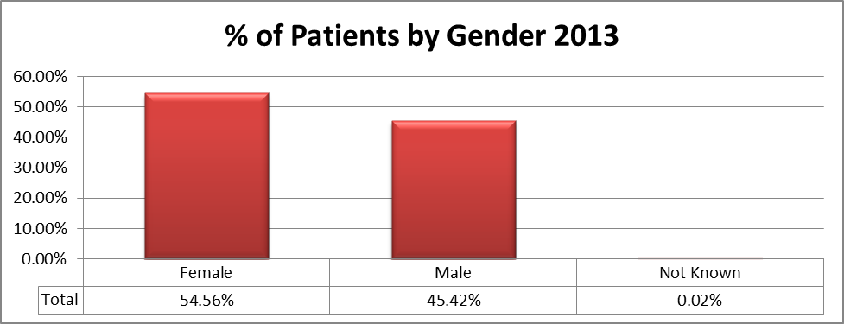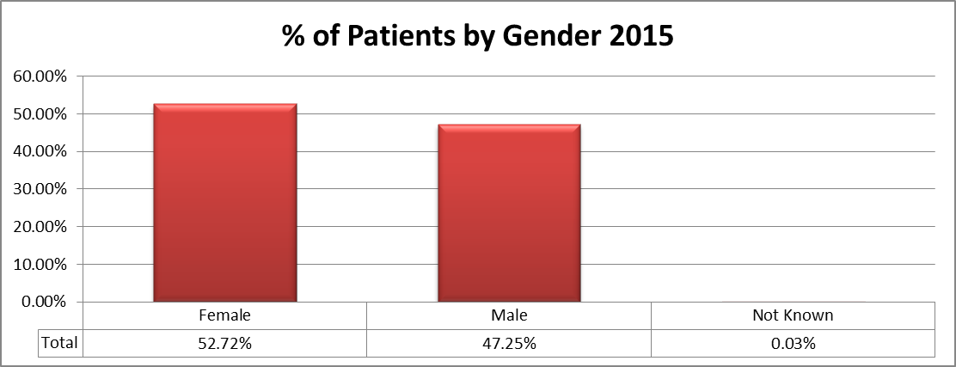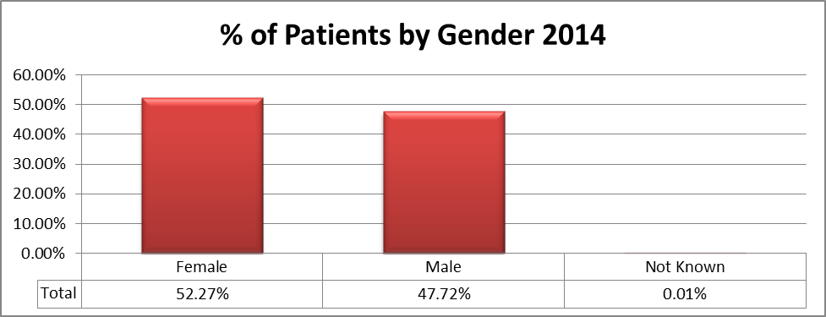

Table 2 – Patients by Age:
This table shows that the age group of 30 to 44 continues to be the highest age group using our services, although there is a reduction of almost 2.02%, a total of 4.7% over the comparative year’s%. There is a slight decrease in the 45 to 59 age group of 1.8% from 2013 to 2015.

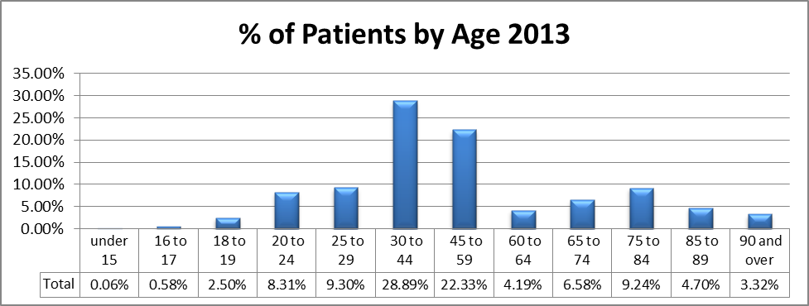

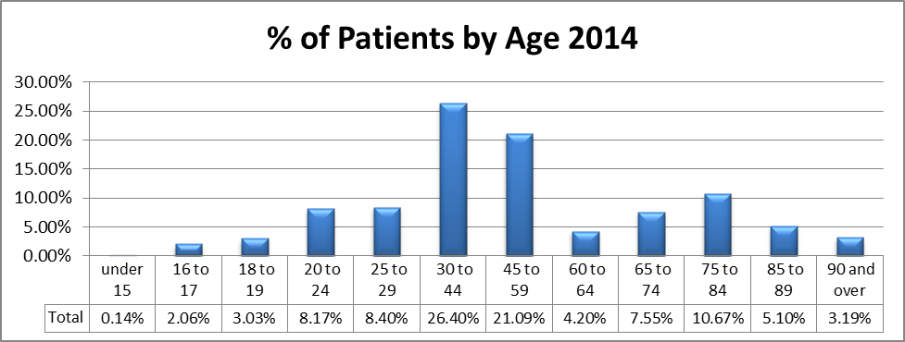

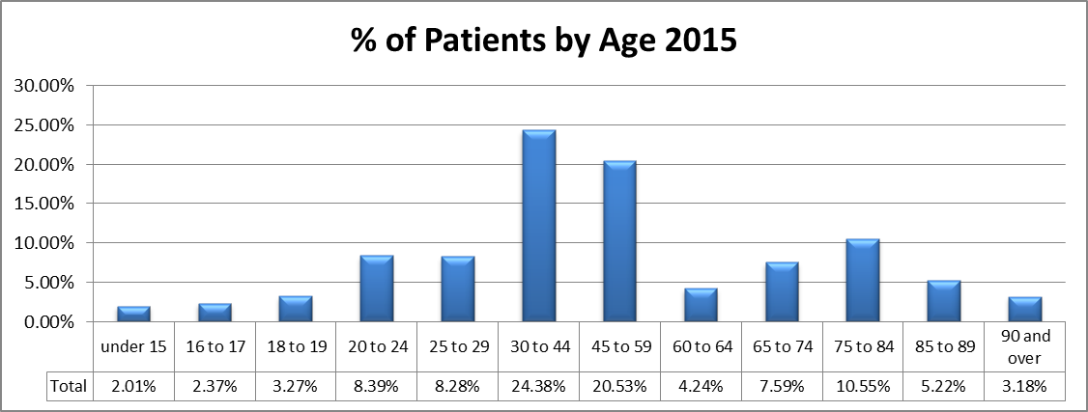

Table 3 – Patients by Marital Status:

The area of “Not Known” remains high and shows a slight increase on the 2014 figures.

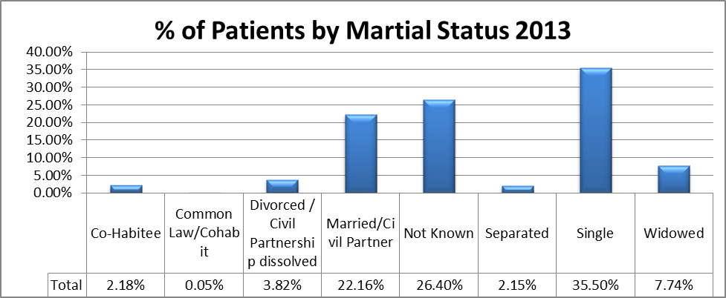

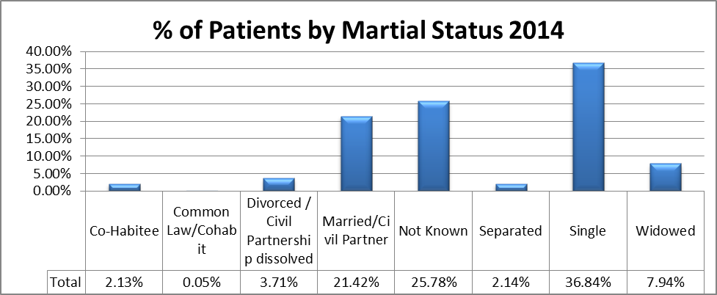

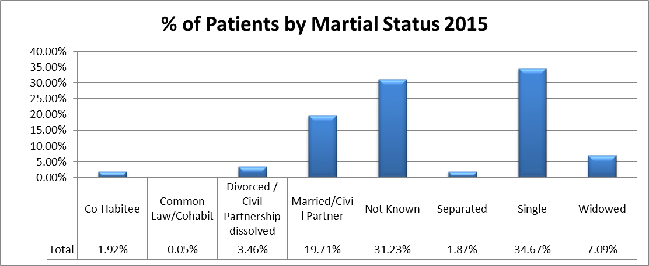

Table 4 – Parients by Sexual Orientation:
This table shows that the area of “Not Known” remains high at 80.46% and a return to the 2013 figure.
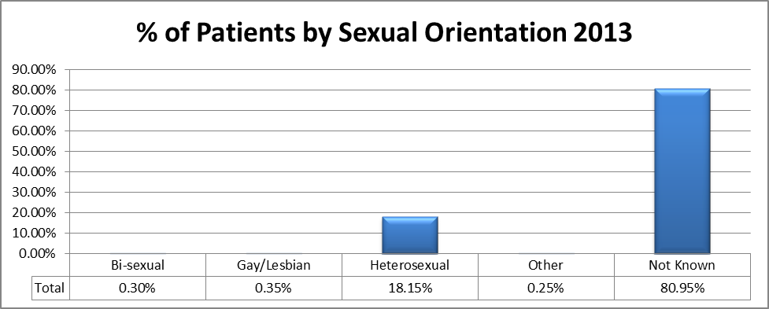

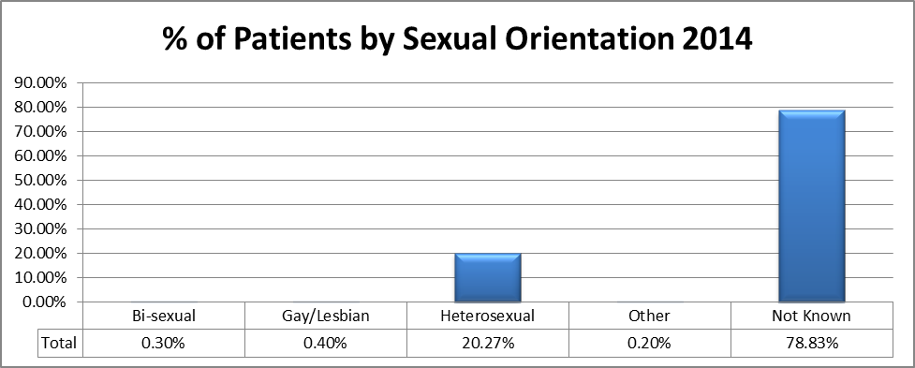

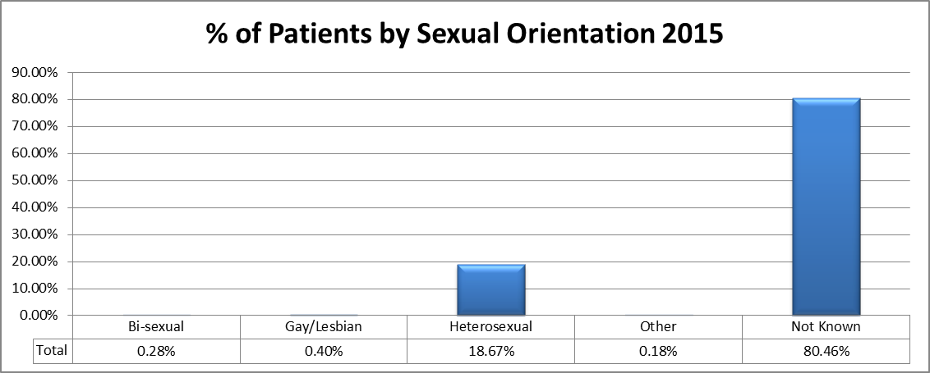

Table 5 – Patients by Disability:

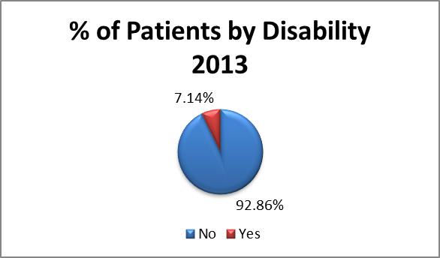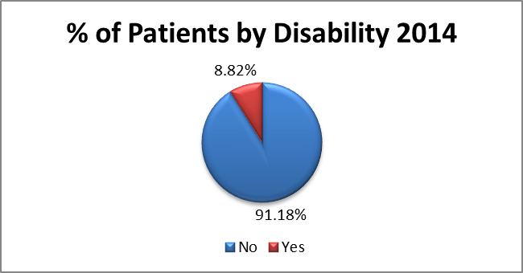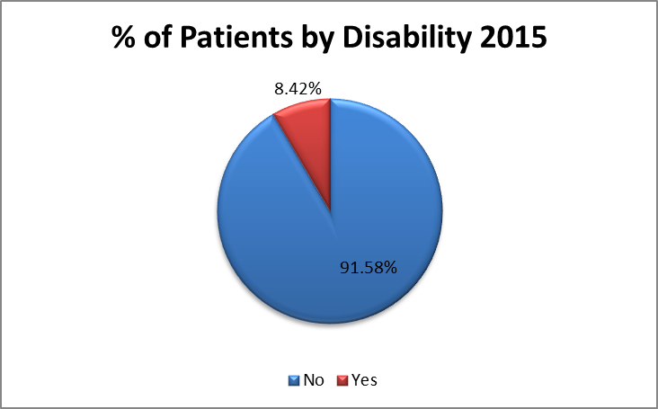

Table 6 – Patients by Disability – Hearing:

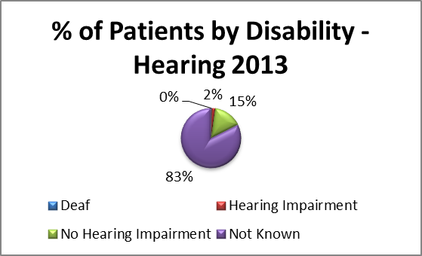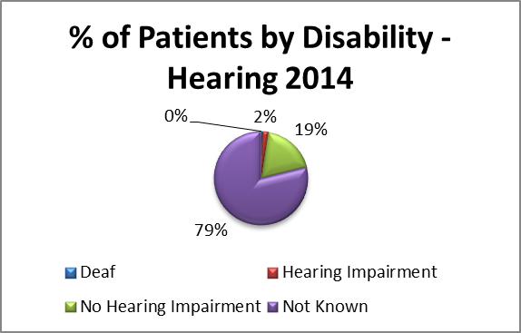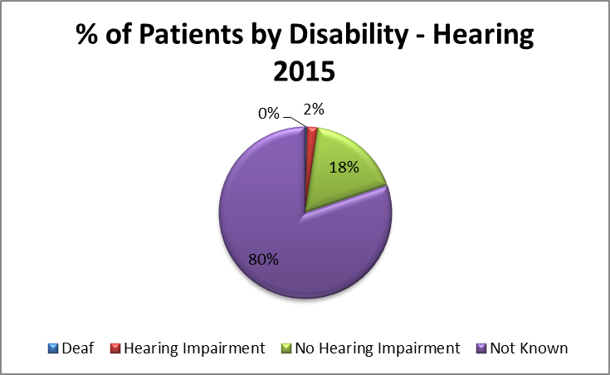

Table 7 – Patients by Disability – Sight:

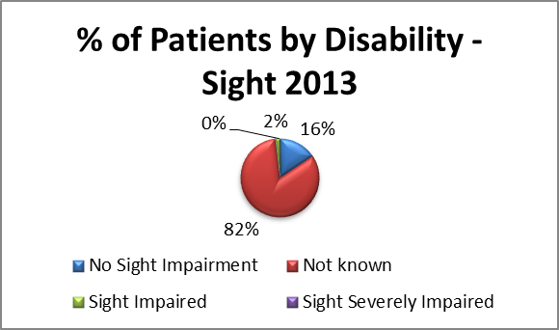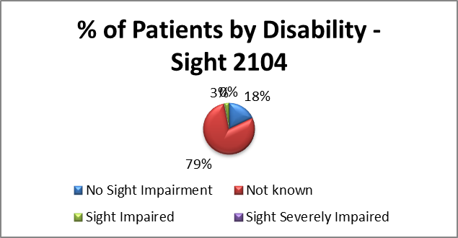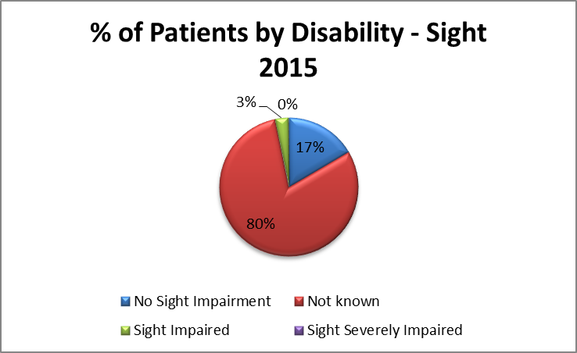

Table 8 – Patients by Disability – Mobility:

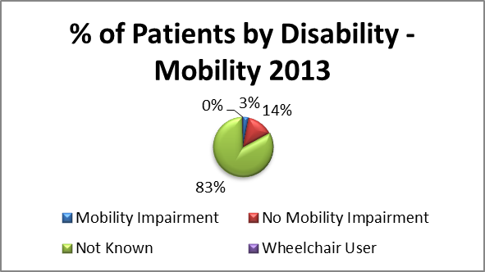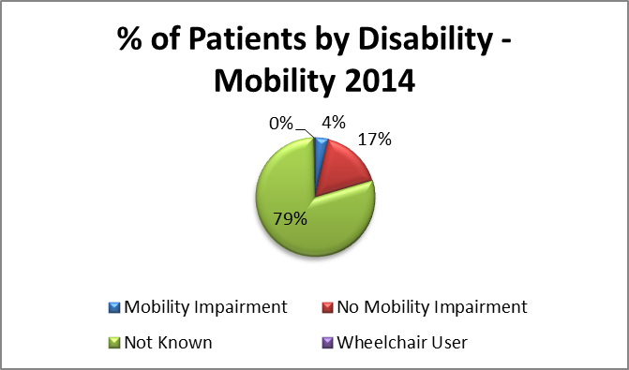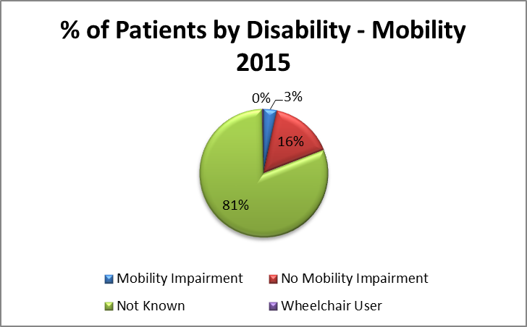
Table 9 – Patients by Disability – Autistic Spectrum Disorder:

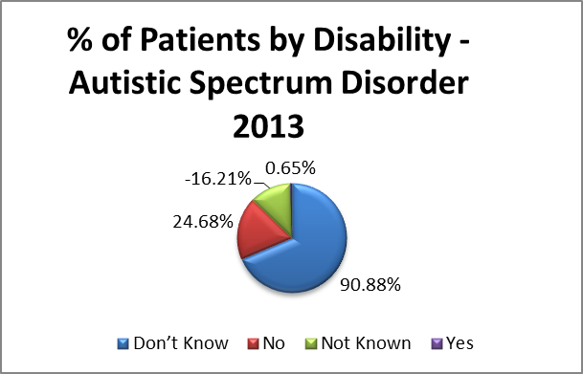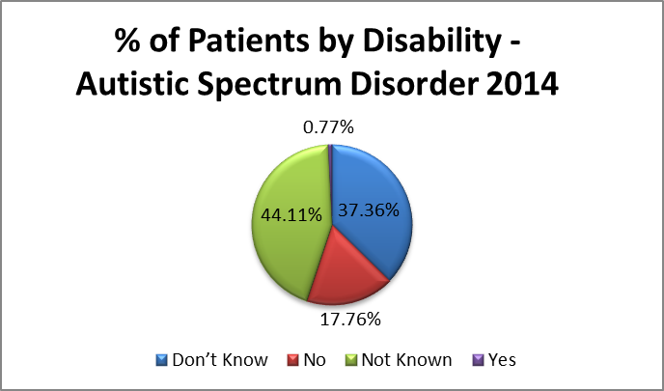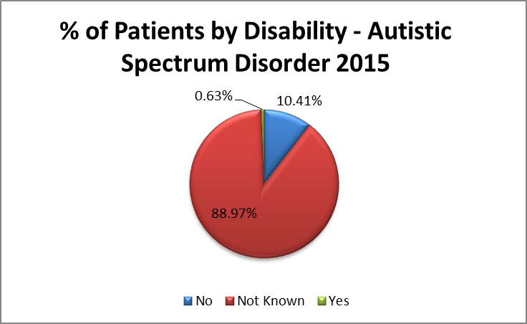

Table 10 - Patients by Disability – Learning Disability

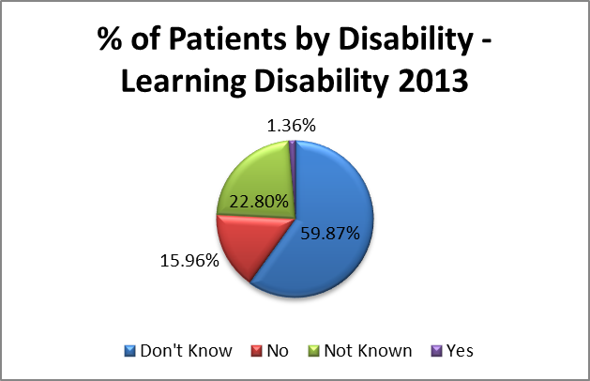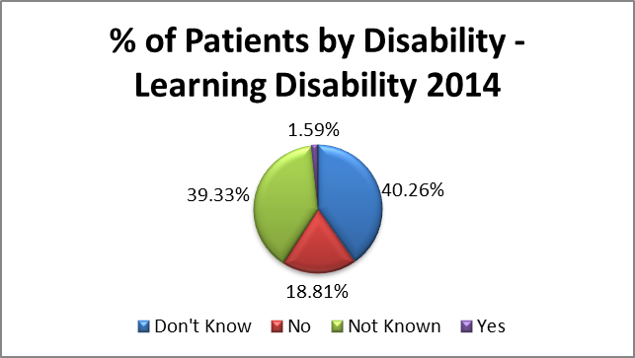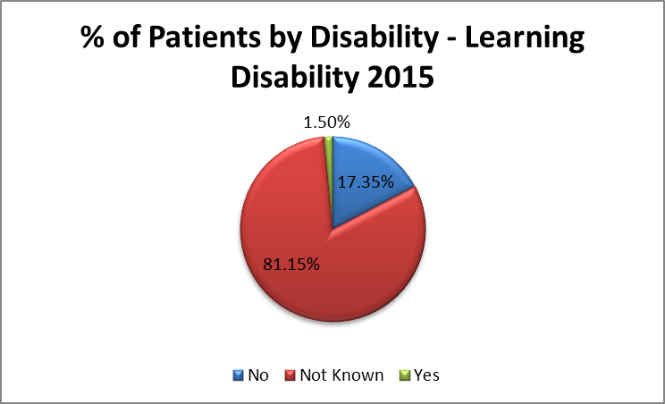

ll of the above areas of disability show that there are high rates of “not Known” in the information being gathered for 2015 and this remains consitently high over the years being assessed.
Appendix 3

BIRMINGHAM AND SOLIHULL MENTAL HEALTH NHS FOUNDATION TRUST

Workforce Subcommittee
Title of Report: Workforce Data Verification Exercise 2015
Action: For information and discussion
Summary:

In order to improve the quality of data information on ESR a data verification exercise was conducted during Q2 of 2015. The table below provides a breakdown of the responses from staff as a result of the exercise.

Equality Field | July 2014 | July 2015 | August 2014 | August 2015 | September 2014 | September 2015 | Total 2015
Disability | 22 | 9 | 38 | 19 | 15 | 8 | 36
Religion or Belief | 18 | 13 | 26 | 16 | 7 | 12 | 41
Sexual Orientation | 23 | 13 | 26 | 14 | 9 | 18 | 45
Nationality | 0 | 19 | 29 | 14 | 12 | 15 | 48
Ethnic Origin | 0 | 6 | 9 | 7 | 13 | 4 | 17
Country of Birth | 0 | 25 | 41 | 20 | 17 | 21 | 66
Others | 700 | 780 | 861 | 414 | 293 | 1119 | 2313
Grand Total | 763 | 865 | 1030 | 504 | 366 | 1197 | 2566
Total Equality Data Changes requested |  |  |  |  |  |  | 253
Although there was quite a significant response generally for changes to data fields, the table below demonstrates that the response to equality data is still quite low with a combine total of 253.
 | December 2013 |  |  | September 2014 |  |  | December 2014 |  | September 2015
Equality Field | No. of Completed Fields in ESR | % Complete |  | No. of Completed Fields in ESR | % Complete | % Change +/- | No. of Completed Fields in ESR | % Complete | No. of Completed Fields in ESR | % Complete | % Change +/-
Disability | 2,651 | 64.4% |  | 2,938 | 70.2% | 5.8% | 3,002 | 70.85% | 4,037 | 97.91% | +27%
Religion or Belief | 2,572 | 62.5% |  | 3,156 | 75.4% | 12.9% | 2,574 | 60.75% | 2,604 | 63.16% | +2.41
Sexual Orientation | 2,434 | 59.2% |  | 3,036 | 72.6% | 13.4% | 2,547 | 60.11% | 2,596 | 62.96% | +2.85
Nationality | 2,059 | 50.0% |  | 2,300 | 55.0% | 4.9% | 2,379 | 56.15% | 2.309 | 56.00% | -0.15
Ethnic Origin | 3,836 | 93.2% |  | 3,948 | 94.4% | 1.1% | 4,016 | 94.78 | 3,869 | 93.84% | -0.94
Marital Status | 3,368 | 81.9% |  | 3,494 | 83.5% | 1.6% | 3,533 | 83.38 | 3,456 | 83.82% | +0.44
Gender | 4,114 | 100.0% |  | 4,184 | 100.0% | 0.0% | 4,237 | 100% | 4,123% | 100% | 0
The committee in therefore ask to consider the following:

- Repeating the exercise year on year in order to demonstrate continuous improvement.
- Additional initiatives to communicate the requirement for collecting data information.
- Poster campaign
- Line management team meetings to communicate the importance of declaring personal data
- Part of RMS/appraisal discussions

Note:
As a requirement of the Public Sector Equality Duty, the Trust will next require to publish workforce information in January 2016. The collection and improvement of this data will support the delivery of the Workforce Race Equality Standards.
Author of report: Bruno Daniel
Appendix 4
Black History Month Celebration and Regional Conference
20 November 2015
Section | 1 | 2 | 3 | 4 | 5 | Number of people who Scored this section | No Score provided | Total Score | Average Score
Welcome – Dr Peter Lewis | 1 | 2 | 9 | 20 | 24 | 56 | 6 | 132 | 4.1
Unexpected Connections – Gary and Helen | 0 | 2 | 8 | 15 | 31 | 56 | 5 | 243 | 4.3
Making Meaning 1 – Chandni Patel | 2 | 2 | 7 | 24 | 19 | 54 | 7 | 218 | 4.0
Moments of Discomfort – Wendy Irwin | 0 | 2 | 6 | 14 | 34 | 56 | 4 | 258 | 4.6
Skills Build - Wendy Irwin | 0 | 2 | 3 | 21 | 29 | 57 | 3 | 243 | 4.2
Making Meaning 2 – Chandni Patel | 1 | 2 | 5 | 28 | 17 | 53 | 8 | 217 | 4.0
Surprise Energiser | 1 | 1 | 5 | 13 | 35 | 55 | 3 | 245 | 4.4
My Journey Here – Yasmin Khan | 0 | 1 | 11 | 24 | 20 | 56 | 3 | 221 | 3.9
Making Meaning 3 – Paul Deemer | 1 | 3 | 14 | 24 | 15 | 57 | 3 | 220 | 3.8
Award Ceremony – John Short/Faheem | 1 | 0 | 6 | 10 | 31 | 48 | 11 | 214 | 4.4
1 Step Closer | 1 | 1 | 2 | 18 | 18 | 40 | 18 | 171 | 4.2
Overall Conference | 0 | 2 | 4 | 12 | 27 | 45 | 11 | 199 | 4.4

Feedback Comments

Section | Feedback
- Welcome  Dr Peter Lewis | - Excellent  - Just had a problem parking – but not your fault  - Bruno very talented and easy to engage with  - Made me feel at home and comfortable  - From beginning to end, the day has been brilliant, fully enjoyed it!  - Apology came in a bit late – 15 minutes late  - Noticed – sign on floor “It’s good to see you” Think we should keep.  - Set the scene for the day. PL. Update from Bruno. Powerful song from Nina Simone  - Very friendly and welcoming  - Good
- Unexpected Connections  Gary Roberts and Helen Billings | - I enjoyed Gary’s elements, but not so much Helen’s. I felt in video she was not interested in listening to Gary  - Helped me to realise I was not the only general nurse in the conference  - Brilliant  - Thought provoking ☺  - Interesting approach to most complex issue  - Interesting  - Was interesting, transparent and brave  - Interesting take from Gary’s side – beware black on Asian, black on black issues  - Interesting and thought provoking  - It wasn’t clear that this session happened  - Powerful information. Presentation mostly reflection on past and present way of life  - Video very good, thought provoking!  - An engaging conversation with ideas and portraying the early years of different races and outlook of each other where we are now….  - Promotes lateral thinking  - Showed their early experiences – How influences them now ‘open and honest’  - Good balance  - Very thought provoking and interesting to see ideas about diversity from another view point  - Importance of conversation established. I think some complex issues were glossed over  - Lots of info: people stories certain situations but nothing that helps me in those situations but helps me think about – But now I get it. I am enjoying the day  - Very Good  - Good
- Making Meaning 1  Chandni Patel | - I was afraid to make wrong judgment  - Good to move and meet others  - Would have liked more time – Very interesting. Real tools for real topic  - Good speaker, inspirational  - Thought provoking and ……… which is why I came  - Beware making snap judgements  - Good to expand on the purpose of doing  - Interesting concept  - Making points of connection is useful but this exercise did not go anywhere  - Good
- Moments of Discomfort  Wendy Irwin | - Wendy was inspirational. Wendy should be a fixed agenda item.  - This section brought to my attention situations I have encountered before  - Brilliant  - Excellent tools to help difficult conversations  - Eye opening  - Reasonable food for thought  - Good basics but I recognise it as awareness raising  - Honest – Which I valued. Good examples were given  - Will remember the rules of making difficult conversations  - Talk – Talk in safety –talk beware of covert discrimination  - Very open and honest – Down to earth  - Engaging presentation  - Related to issues  - Thought provoking  - Very powerful presentation about our lives, caring professional and use for the future  - Found it difficult to judge at face value. I like to think the best of everyone!! Loved the pictures!!  - Difficult to judge other people. Did I do it right?  - Learning lesson – Not to be judgemental on first impression  - Excellent – Thought provoking  - Keeps engaged – very relevant > gave tips/lots to take away  - Express yourself – courageous conversations  - Excellent  - Eloquently put across with real feeling  - Wendy – Very good presenter. However the invitation to disclose prejudice/prejudgment allows largely unchallenged particularly some comments made  - Interesting > Made me think about who I am – How I behave  - Excellent  - Excellent – Take away lots of useful knowledge
- Skills Build  Wendy Irwin | - Not enough space to do the actions due to design of the room. More boards around the room or pictures on tables. Thought provoking  - Brilliant  - Good basics but I recognise it as awareness raising  - Great to have opportunity to think about skill for building skills  - Inspirational  - Wendy is a very good inspirational speaker  - Very powerful presentation about our lives, caring professional and use for the future  - Uncomfortable of them to give feedback to people who don’t accept you for who you represent  - Helpful and educational  - Very enjoyable and interactive  - Helpful and enjoyable practical application  - Excellent exercise, encourage deeper thought processes and observational skills  - Equality street – Thought provoking, reflect on ones beliefs and values  - Helps to show how everybody judges and when they don’t want to admit it  - Not lover of this - thanks for the stone  - Very Good  - Excellent
- Making Meaning 2  Chandni Patel | - A little confusing as to what to do  - Lovely  - Reasonable food for thought  - Revealing exercise  - Got lost  - Good  - Good  - Post its  - Made me think  - Good
- Surprise Energiser | - Fun, relevant and motivating  - Angela was great and looked amazing > Loved her dress.  - A good surprise  - Love singing – so loved this  - Marvellous  - WOW – Fab  - The lunch, the music and entertainment was fab  - Excellent! Fun ☺ Should be done under caution, my energy levels went through the roof  - Good idea for the session – But 1. Should have been shorter. 2. Poor stereotyping of BME Women  - Good fun  - Fun  - Brill – Just what you need after lamb curry and rice  - Really enjoyed this  - The days when black women had to be caricatures for the purpose of entrainment are long gone and have no place at an event like this. The singing was fine but the young lady who was singing had padding on certain areas of her body that perpetuates the stereotypes of black women. I cannot believe that no-one stopped to think this inappropriate.  - Nice touch  - Thanks for the entertainment – Cocoanut Woman!  - Not as engaging as I thought it would be  - Very enjoyable  - Great fun and burnt off some cake  - Lovely songs and woke me up and very comforting  - Excellent – after lunch appetizer. Good to shake off the food given  - Excellent and back in the 60’s music  - Very good and enjoyable after lunch  - Fantastic wake – Superb lunch loved the music and singing – Albeit I am not a singer – Still sung along and had a dance!  - Where was the speaker – Singing was excellent 5*  - Excellent – Really prevented the afternoon lull  - Excellent – both vocalist and musician  - Fun – Relevant and motivating  - Great – Brilliant idea  - Wasn’t energiser – They said to move around the room – no one….  - Good
- My Journey Here  Yasmin Khan | - Yasmin was a little boring and it was disappointing that she didn’t answer her questions. Complete opposite – Paul was great and enjoyed the Haiku exercise  - Good example of what is positive – well done Yasmin  - Lucky woman – Fabulous that she took charge of opportunities but she very young and the road hard and many have died in vain  - Good to hear story, but so what’s Yasmin’s role and how common it is a woman topic session – i.e. significance of henna in Asian culture  - Inspiring  - Empowering and Unexpected Connection to my education life  - Inspiring life story  - Very interesting  - Lovely of Yasmin to share her experience of hardship  - Inspirational  - Interesting story and journey  - Very humble  - One very hard working person  - Would have been nice to have more information about Yasmin but very good  - Excellent
- Making Meaning 3  Paul Deemer | - Motivational, encourage to try new skills  - Interesting  - Not really useful  - Does not help the issues BME Staff f and patients face!  - Paul Deemer – interesting  - Fun  - Missed opportunity to introduce – got lost here  - Struggle to make the connection  - Nicely pulled together poem  - An interesting poetic session, good to learn a basic knowledge of Haiku  - Very interesting  - Haiku – Enjoyed  - Somewhat confused  - Didn’t really get it – could not create a poem but have written a lot – Oh, 'no, I wrote a poem! Nice to work together and chat with so many new colleagues from other professions and backgrounds
- Award Ceremony  John Short/Faheem | - Very well deserved  - Well deserved  - Well deserved  - Sorry had to leave  - Always good to award staff something positive  - Faheem deserves it – He works very hard for the Trust  - Faheem – Excellent  - Well done Faheem  - A great speech from Faheem- re 2 ways to succeed C/o of his mum!  - Faheem is an inspiration, good of Trust to recognise him for his work  - Very uplifting  - Nice to see one of the people we serve being celebrated  - Really good to see Faheem get recognised he deserves it  - Empowering and encouraging and very exceptional person  - Very well deserved  - Well deserved – nice to see appropriate recognition  - Very well deserved  - Inspiring and warm  - Put it at a different time? In the morning before lunch  - Very Poignant  - What an inspiration  - Please do not play music when reading the poetry
- 1 Step Closer | - Did this happen  - Good though could not lip read so don’t have ….  - Poems – Not a good use of time. Authors are not a problem in the workplace  - Creative  - Oh WOW – Creativity is inspiring. Demonstrate the breath and complexity of diversity  - Good closure to a great day
- Overall Conference | - Important messages  - Excellent – however may be useful to have inclusion of diverse communities in Birmingham area as Birmingham is just as diverse  - Great day. Food was good but better last year!!  - It was different , thought provoking, inspiring and has given me more ways to connect in the right ways  - Thank you for a great day  - Inspiring  - Nice to meet new people  - Generated ideas for work  - Most enjoyable  - Nice venue  - Good food  - Excellent event  - Really liked the conference booklet to make notes and keep. Loved the stones exercise  - 1. Thanks Bruno. 2. Delivery good. 3. Great to meet new colleagues  - Interesting seminar – but nowhere near as it been stated what stream for making race empathy happen. Personally I need much more from a conference on diversity in healthcare  - Interesting awareness raising conference. Different from expectations. Great buoyancy of lead speakers  - Unfortunately could hear – Hearing impairment  - Soft skills session valuable. Thank you  - Fun interactive interesting, eye opening, informative welcoming and friendly  - Very interesting day. Reflection on every day thoughts  - Always remember Unexpected Connections in diversity  - Bruno’s interesting changing in behaviours was very apt and was my “Light Bulb” moment of the day  - Important messages  - Very thought provoking event  - Music interlude was very welcome. Very upbeat. Food excellent  - Very interesting and great to meet inspirational and like-minded people  - It has been a great day. Thank you for organising and every presenter for coming.  - Well-presented and very informative and above all useful in professional and retired life  - Coffee break after lunch was too long. We had a big lunch so no need for another long coffee break. Rather finish seminar off earlier to go home and beat the traffic!!  - Excellent experience  - Very entertaining and inspirational conference with full of engagement and activities – not forgetting the lovely music  - I attended last year and was excellent – This year different but still excellent. Would highly recommend to others to attend. Happy☺  - One of the best conferences I have ever been on!  - Excellent day – really thought provoking  - Thank you for a lovely lunch as well and for a great massage by the complimentary therapist in the market place  - Very good and interesting concept, making me explore more deeply  - Amazing day – Lack of snacks at breaks, found it really difficult to navigate around the room. No space but kept getting asked to move around  - Brilliant – Thank you  - Excellent and Informative conference. It has left me with many thoughts  - Coming from a surgical background, this has been a very different conference to what I have been used to  - Good successful enjoyable conference, venue and food great – Thank you
- Additional Comments | - Lunch was very good  - Steel Band / Musician was fantastic and a real treat over lunch  - Complimentary therapy was also good.  - Lunch 5  - Well put together, interactive and engaging  - Lunch was lush  - No hearing loop system so only a vague idea what the day was about I usually call venue ahead of time to check but I only got taken off the waiting list, last minute so didn’t get time to phone the venue this time.  - LOVED LUNCH! ☺  - Lunch was amazing  - Poem – Why? Why? Why?  ….Who am I aiming this at?  ….In the end it begins and starts with me!  - Technical aspect were a bit clunky  - Lunch was fab! Thank you ☺  - Lunch was great

Appendix 5 goes here

